Neural Network

# What is a neural network :

* **Neuron** -> A thing that holds a number.
* Example : The Network starts with a bunch of neurons corresponding to each of the 28x28 pixels of the input image, which is 784 neurons in total.
  + Each one of these holds a number that represents the grayscale value of the corresponding pixel, ranging from 0 for black pixels up to 1 for white pixels.
* The number inside the neuron is called its **activation**.
* **Neural network**:
  + The **range** is from 0 to 1.

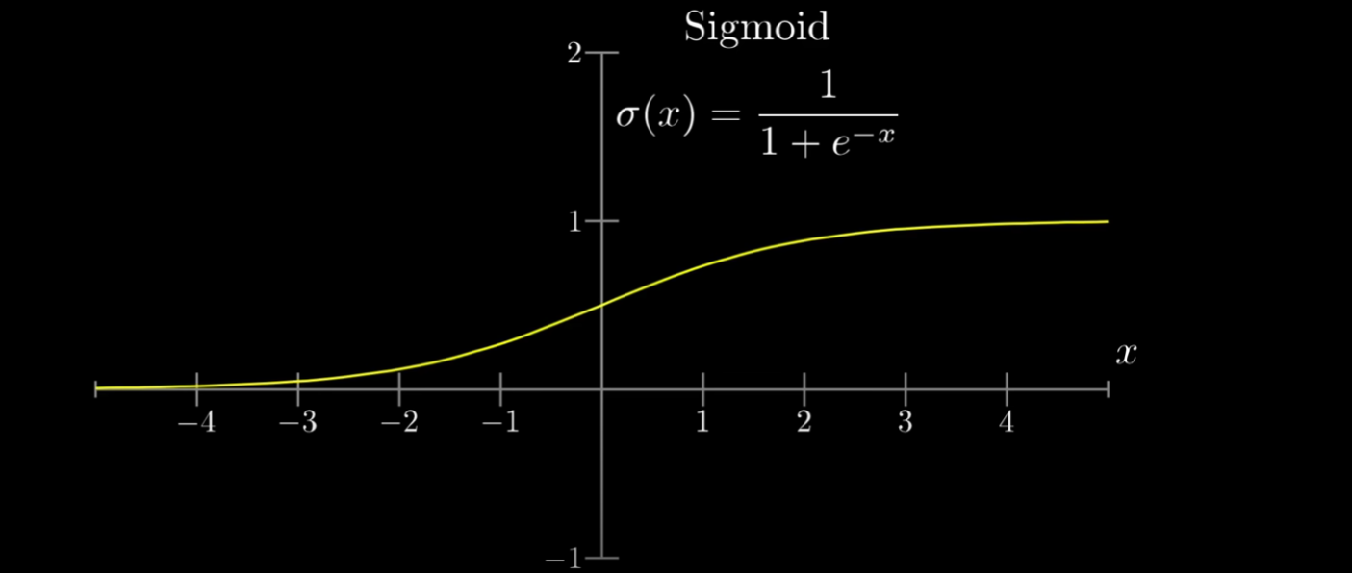

* + The **layers** kinda like many subcomponents of a component: such as

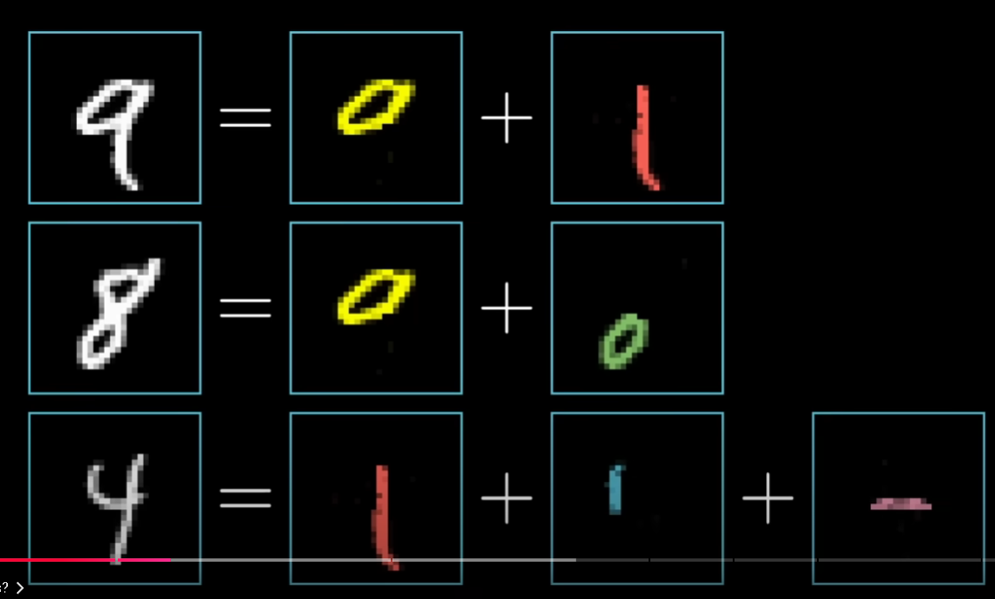

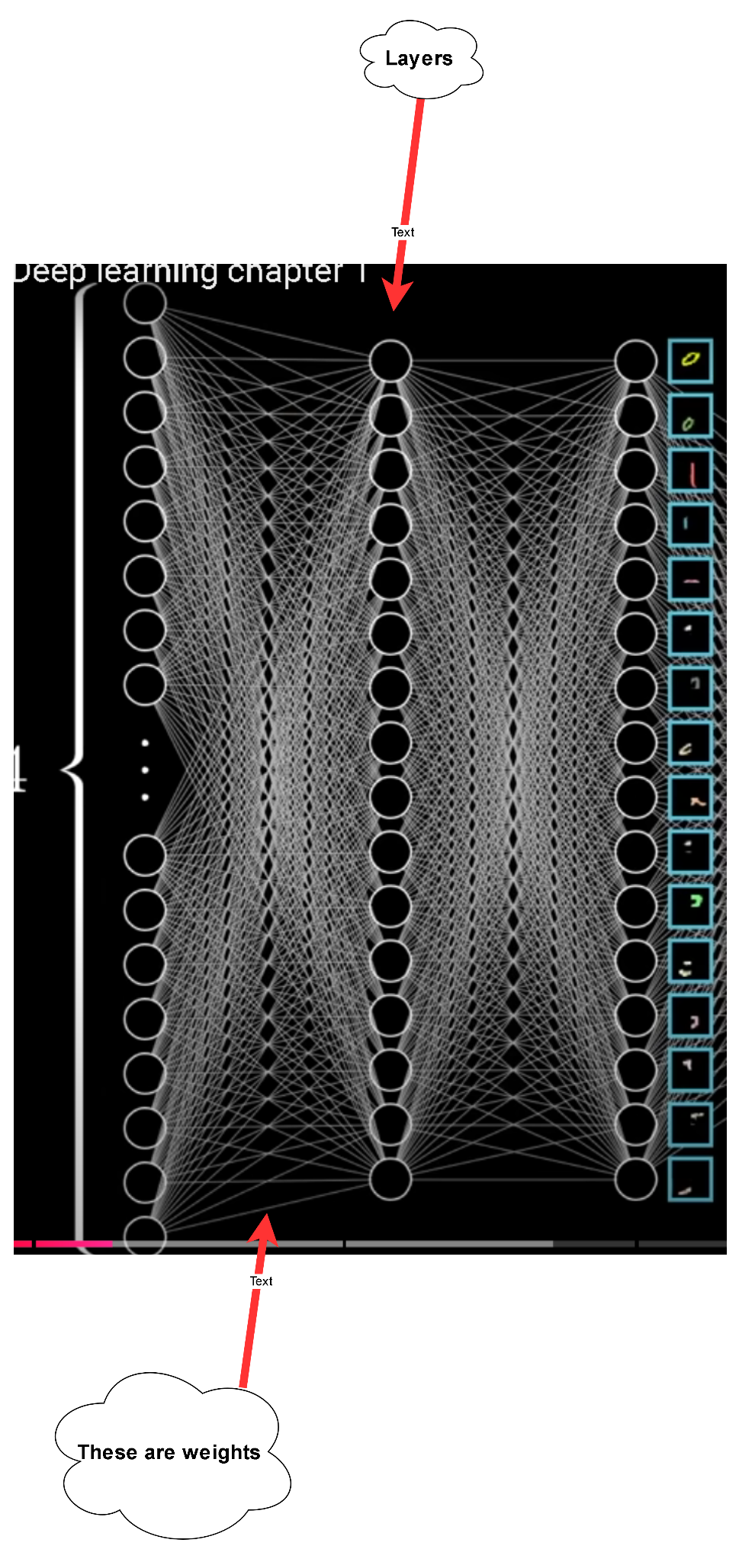

* + - From the left to right, the layer is going to combine subcomponents to complete components.

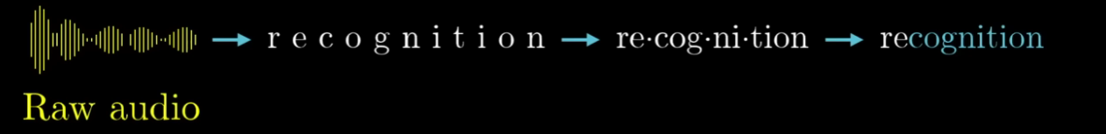

* Components :
  + **Inputs** : They’re usually represented as features of a dataset which are passed on to a neural network to make predictions.
  + **Weight** (*hệ cơ số a, b, c,..*): These are the real values associated (*lquan* ) with the features. They are significant as they tell the importance of each feature which is passed as an input to the artificial neural network.
  + **Bias** (*độ lệch*): Bias in a neural network is required to shift the activation function across the plane either towards the left or right.
  + **Summation function** : It is defined as the function which sums up the product (*tích*) of the weight and the features with bias.
  + **Activation function** : It is required to add non-linearity (*tính phi tuyến tính*) to the neural network model.
* Example : A pixel 28x28 = 784 times
  + The total biases of neural networks =   
    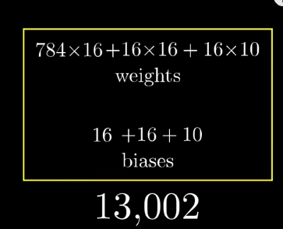
* The **Learning** -> Finding the right weight and biases.
* **Notation and linear algebra** :(ký hiệu, đại số tuyến tính)

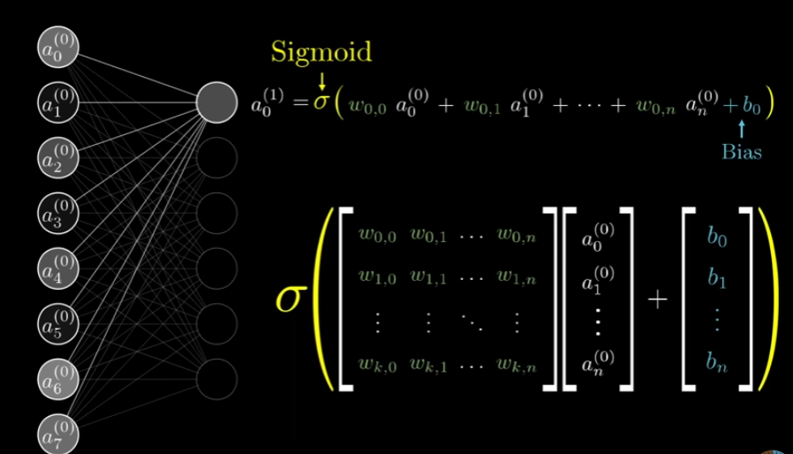

=>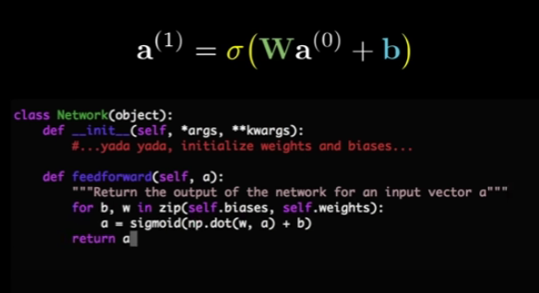

* Neural as a function that takes in the outputs of all the neurons in the previous layer and spits out a number between 0 and 1.
  + Such as : takes in 28x28 = 784 numbers as an input and spits out 10 numbers as an output.

Gradient descent

# Gradient descent : (*thuật toán tìm max min*)

* -> Underlie not only how neural networks learn, but how a lot of other machine learning works as well.
  + Example : a 28x28 pixel grid, each pixel with some grayscale value between 0 and 1 -> Determine the activations of 784 neurons in the input layer of the network.

# Using training data :

* An algorithm where we can show the network a whole bunch of training data, which comes in the form of a bunch of different images of handwritten digits, along with labels for what they are supposed to be
  + -> It will adjust those 13,000 weights and biases so as to improve its performance on the training data.
* The layered structure will generalize to images beyond that training data.
  + After training the network -> we show it more labeled data that it’s never seen before and we see how accurately it classifies those new images.

# The cost function :

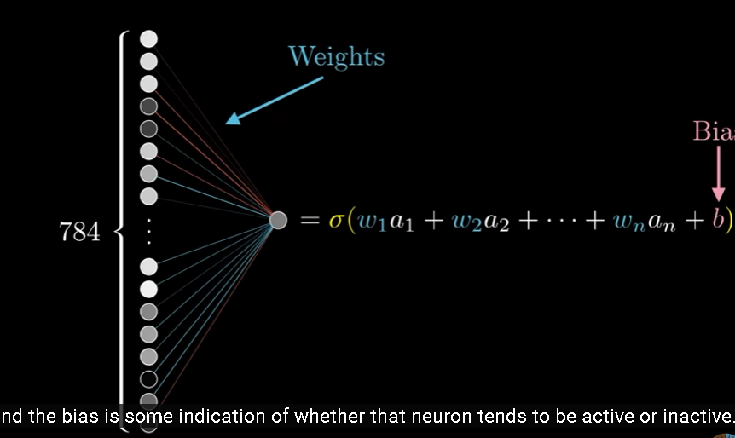

* + A way of telling the bad computer that output should have activations which are 0 for most neurons but 1 for the neuron that we gave to it ‘utter trash’. (we gave it an input)
  + Mathematically : we add up the squares of the differences between each of those trash output activations and the value we want them to have -> Cost of a single training.
    - The sum is small <-> The network confidently classifies the images correctly.
    - The sum is large <-> The network seems like it doesn’t know what it’s doing
  + The average cost is the measure of how lousy the network is, and how bad the computer should feel.

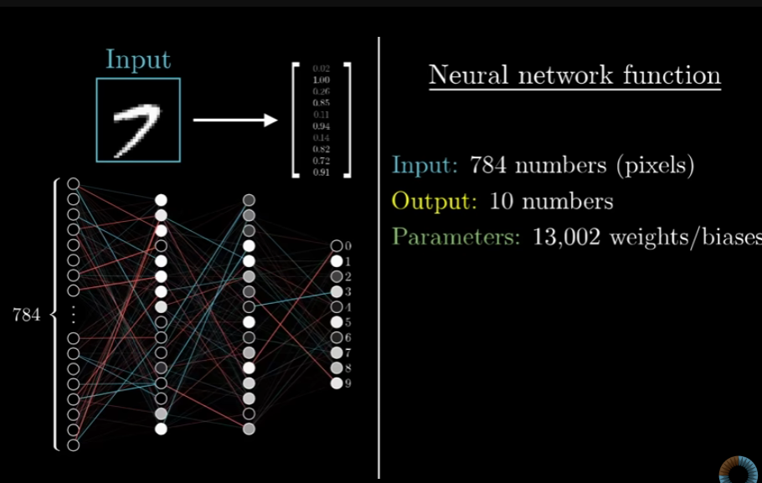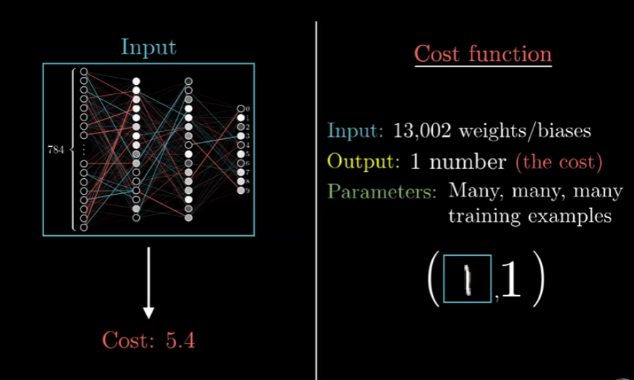

* => We tell it how to change those weights and biases -> it gets better

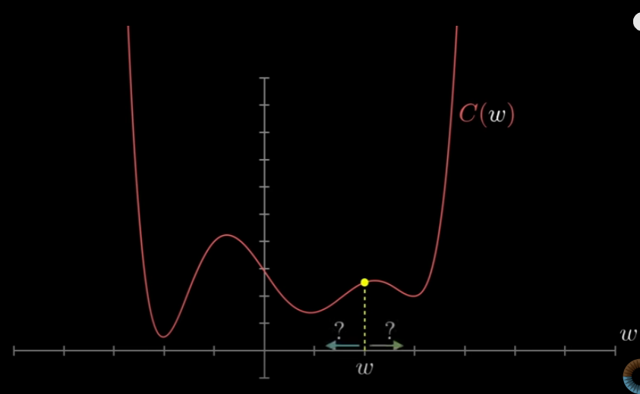

* A more flexible tactic is to start at any input and figure out which direction we should step to make that output lower => Approach some local min of the function.(A ball rolling down a hill).
* There are many valleys that we might land in , depending on which random input we start at, and there’s no guarantee that the local min we land in is going to be the smallest possible value of the cost function.

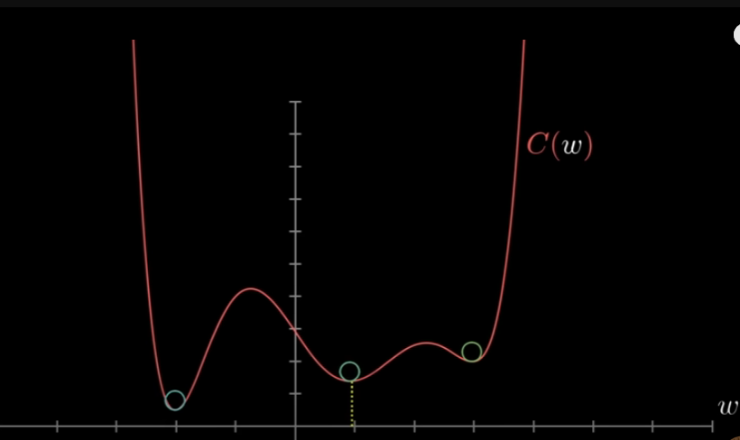

# Gradient descent :

* Image : We have 2 input and 1 output: (xy-plane)
  + Which direction should we step so as to decrease the output of the function most quickly? **<->** What is the downhill direction? (*a ball rolling down that hill*)
  + The gradient of a function gives us the direction of steepest ascent
    - -> Which direction should we step to increase the function most quickly.
  + Taking the negative -> the gradient gives us the direction to step that decreases the function most quickly.
* The cost function involves an average over all of the training data -> If we min it -> it’s a better performance on all of those samples.
* The consequence of that is that it’s important for this cost function to have a nice smooth output -> We can find a local min by taking little steps downhill
* => Artificial neurons have continuously ranging activations rather than simply being active or inactive in a binary way, the way biological neurons are. (*this is telling Artificial neurons not like a machine like binary way but similar to biological neurons*)
* Gradient descent : The process of repeatedly nudging an input of a function by some multiple of negative gradients.
* Each component of negative gradient tell us 2 things :
  + The sign : whether the corresponding component of the input vector should be nudged up or down.
  + The relative magnitudes of all these components : which changes matter (*qtrong*) more.

# More on gradient vectors :

* Is another way of thinking about direction

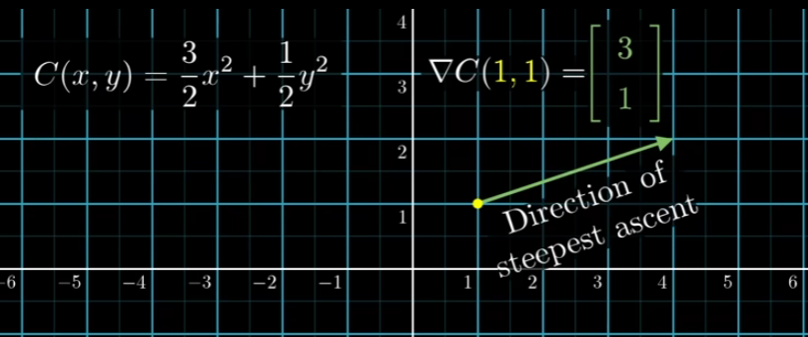

* + The first variable have 3 times the importance as changes to the second variable -> The neighborhood of the relevant (*khu vực lân cận*) input nudging(*thúc đẩy*) the x-value carries a lot more bang for our buck(*giá trị*)

# Gradient descent recap :

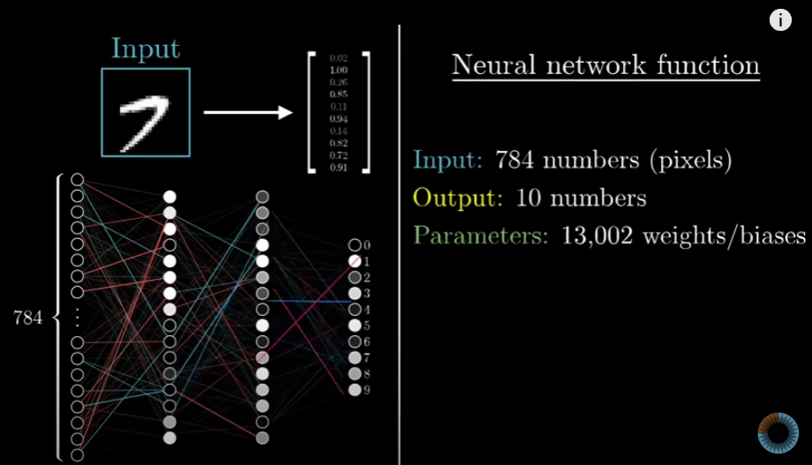

* The cost function is a layer of complexity on top of that :

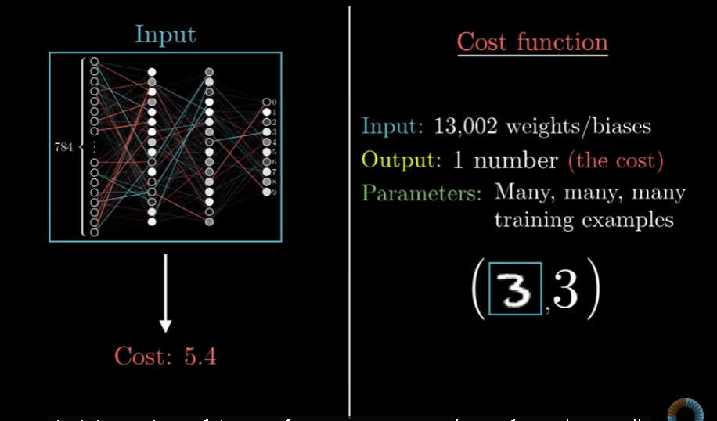

* The gradient of the cost function is one more layer of complexity still -> It tells us what nudges to all these weights and biases cause the fastest change to the value of the cost function -> Which changes to which weights matter the most.

# Analyzing the network :

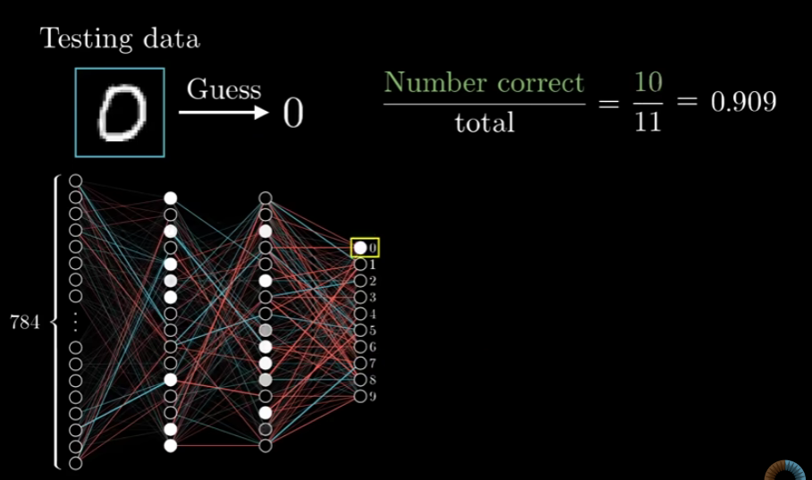

* The second layer might pick up on little edges ; the third layer would piece together those edges to recognize loops and longer lines and that those might be pieced together to recognize digits
* Even if the network can recognize digits pretty well -> It **has no** idea how to draw them because it’s such a tightly constrained (*Hạn chế*) training setup.

Backpropagation

* Backpropagation ; an algorithm for computing the crazy complicated gradient
* The notation and the index chasing :

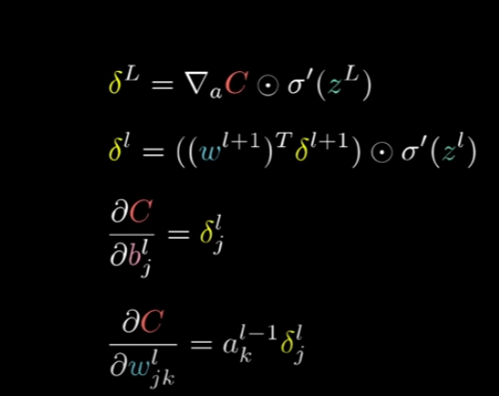

* The magnitude of each component is telling how sensitive the cost function is to each weight and bias.

# Intuitive walkthrough :

* The cost function involves averaging a certain cost per example over all the tens of thousands of training examples -> The way we adjust the weights and biases for single gradient descent step also depends on the single example
* **Example with images of 2**:
  + We are at a point where the network is not well trained yet -> The activations in the output are going to look random

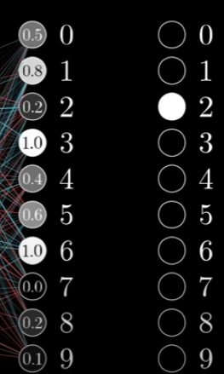 Like 0.5, 0.8, 0.2,...

* + Since we want it to classify the image as a 2, we want that third value to get nudged up while all the others get nudged down ( *like array, number 2 is in the third position* )
  + The size of the nudges should be proportional to how far away each current value is from its target value.
    - The increase number 2 neuron is more important than the decrease to the number 8 neuron
  + The **activation :** is defined as a certain weighted **sum** of all the activations in the previous layer, **plus** a bias, then plugged into something like the sigmoid squishification function or a reLU.

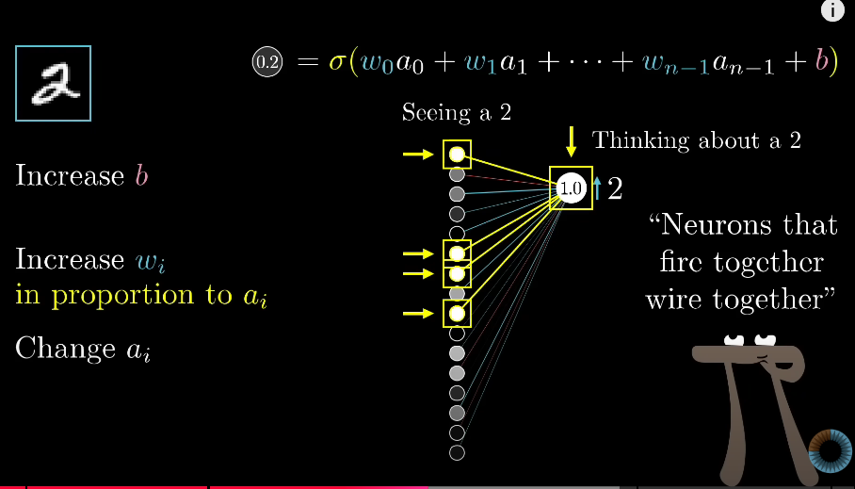

* + **Increasing the weights** (the brightest neurons) -> Has a stronger influence on the ultimate cost function than increasing the weight of connections with dimmer neurons.
  + Hebbian theory : “ Neurons that fire together wire together” -> The biggest increases to weights, the biggest strengthening of connections, happens between neurons which are the most active and the ones which we wish to become more active.
  + Changing all the activations in the previous layer.
    - If everything connected to that digit 2 neuron with a positive -> weight got brighter
    - If everything connected with a negative -> weight got dimmer
    - => Digit 2 neuron would become more active.
  + **Seeking changes (*changes a*)**that are proportional to the size of the corresponding weights. -> Control over the weights and biases.
    - Keep a note of what those desired changes are.
* **Propagate backwards** : Adding together all the desired effects -> Basically get a list of nudges that we want to happen to this second to last layer -> We can recursively apply the same process to the relevant weights and biases that determine those values , repeating the same process and moving backwards through the network.
* If we only listened to what that 2 wanted -> The network would ultimately be incentivized just to classify all images as a 2.
  + => Go through the same backprop routine for every other training example, recording how each of them would like to change the weights and biases, and average together those desired changes.

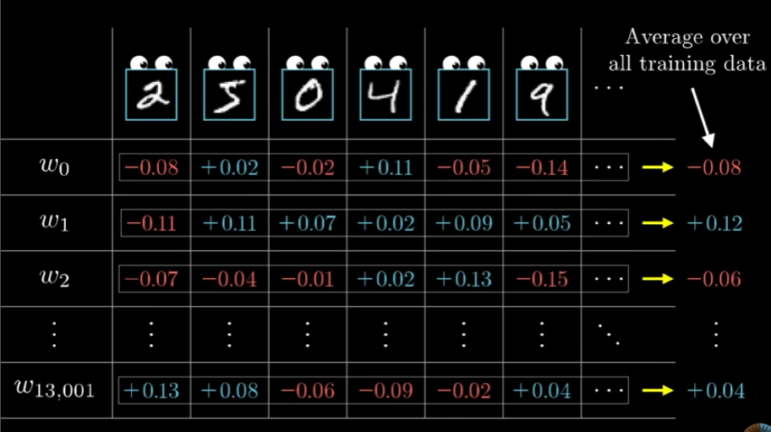

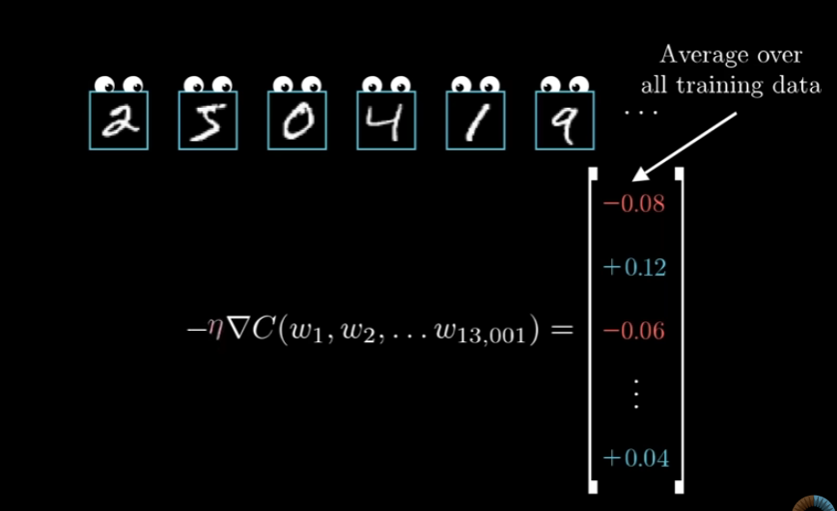

# Stochastic gradient descent :

* Example :
  + We randomly shuffle our training data and then divide it into a whole bunch of mini-batches, each one having 100 training examples.
  + We compute a step according to the mini-batch.
* This is not the most efficient step downhill, but each mini-batch gives a good approximation -> Give a significant computational speedup
* **Backpropagation** : the algorithm for determining how a single training example would like to nudge the weights and biases, not just in terms (*thuật ngữ*) of whether they should go up or down, but in terms of what relative(*tương đối*) proportions to those changes cause the most rapid (*nhanh nhất*) decrease to the cost.
* -> We randomly subdivide the data into mini-batches and compute each step with respect to a mini-batch -> Repeatedly going through all of the mini-batches and making these adjustments -> We will converge towards a local min of the cost function which is to say our network will end up doing a really good job on the training examples.

=> **Backpropagation**: kinda like change or increase or decrease something to decrease to the cost

Backpropagation Calculus

# Goal : Show how people in ML commonly think about the chain rule from calculus in the context of networks - a different feel from how most introductory calculus courses approach the subject.

# The Chain Rule in network :

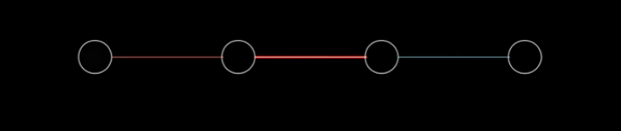

* The **goal** : Understand how sensitive the cost function is to these variable.
  + Each layer has a single neuron in it.
  + This network is determined by 3 weights and 3 biases.
  + Focus on the last 2 neurons :

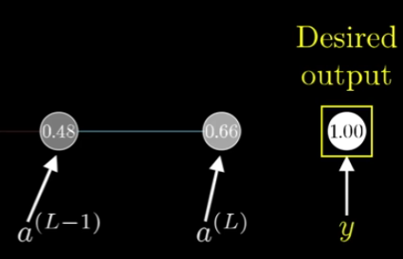

y might be 0 or 1

* + - The cost of this network :   
      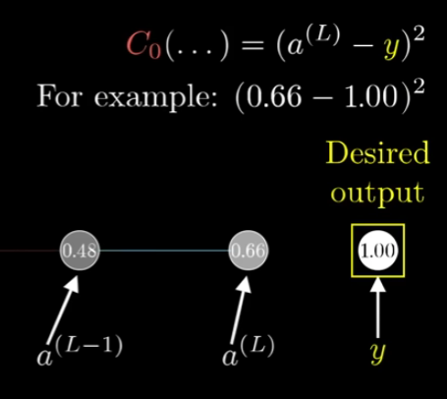
    - The last activation is determined by a weight

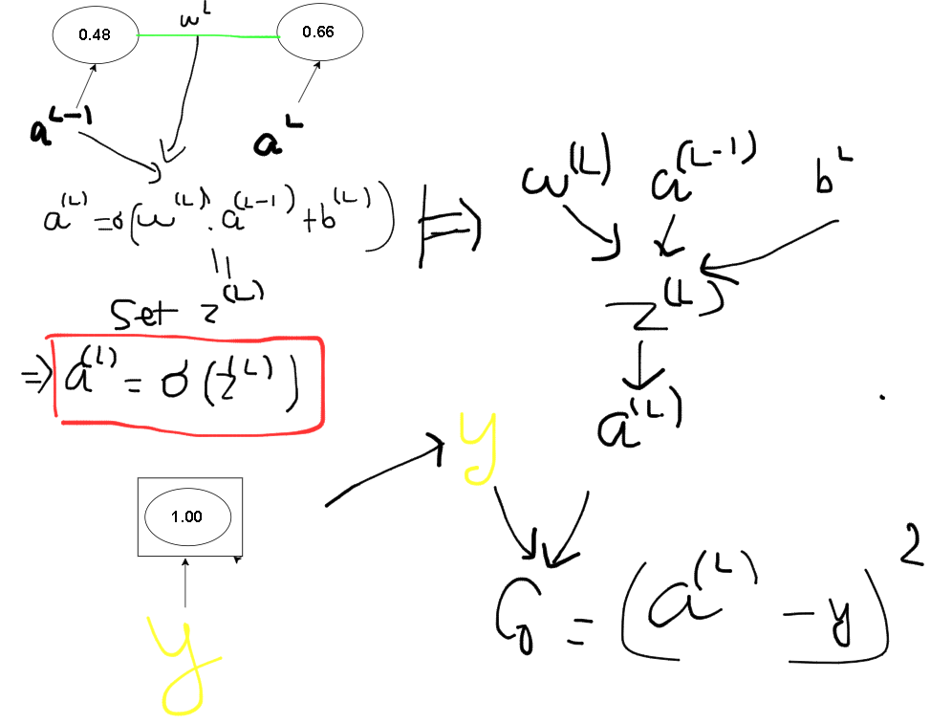

* ??? What is the derivative of Co with respect to $w^{(L)}$ $\frac{dCo}{dw^{(L)}}$
  + $w^{(L)}$: A change by 0.01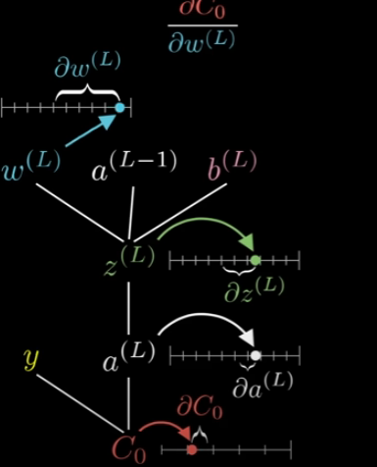
  + Co : Whatever the resulting nudge to the cost is.
  + The chain rule :

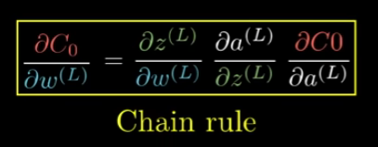

# Computing relevant derivatives & What do the derivatives mean? :

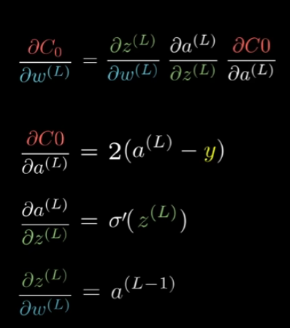

* In the case of the last derivative, the amount that the small nudge to the weight influenced the last layer depends on how strong the previous neuron is <-> The neurons that fire together wire together idea comes in.

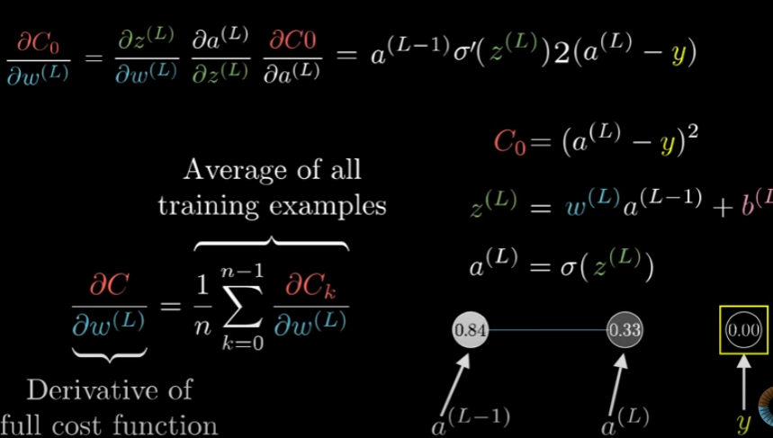

* That is only 1 component of the gradient vector, which itself is built up from the partial derivatives of the cost function with respect to all those weights and biases.

# Sensitivity to weights/biases :

* Both the sensitivity of weights and biases : Just one of many partial derivatives we need -> It’s more than 50% of the work.
* We can change the derivative of Co with respect to any thing in this 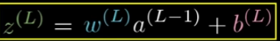(except z(L))
* We can just keep iterating this same chain rule idea backwards to see how sensitive the cost function is to previous weights and previous biases.

# Layers with additional neurons :

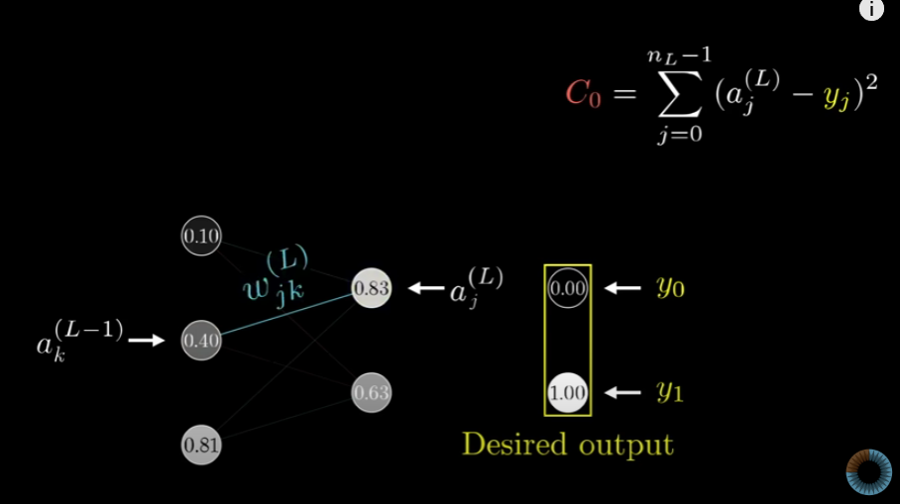

* Since there’s a lot more weights, each one has to have a couple more indices to keep track of where it is.
* Those indices line up with ( *phù hợp* ) how we’d index the weight matrix.
* All of these are essentially the same equations (*phương trình*) we had before (*in II*.), it’s just that it looks a little more complicated.
* The chain-ruled derivative expression describing how sensitive the cost is to a specific weight looks essentially the same.

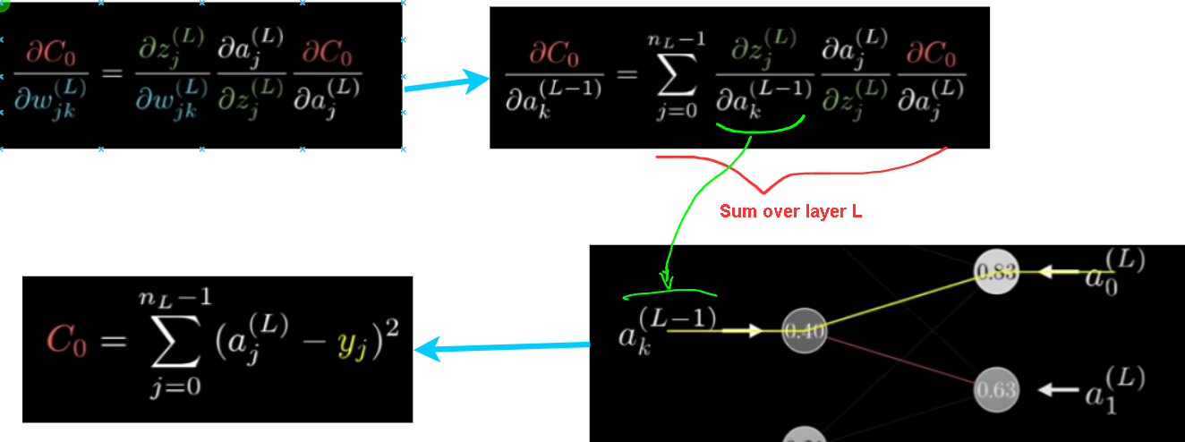

* + The $a_{k}^{(L-1)}$ influences $a_{0}^{(L)}$- Which plays a role in the cost functions
  + The $a_{k}^{(L-1)}$ influences $a_{1}^{(L)}$- Which plays a role in the cost functions
* Once we know how sensitive the cost function is to the activations in this second-to-last layer, we can just repeat the process for all the weights and biases feeding into that layer.

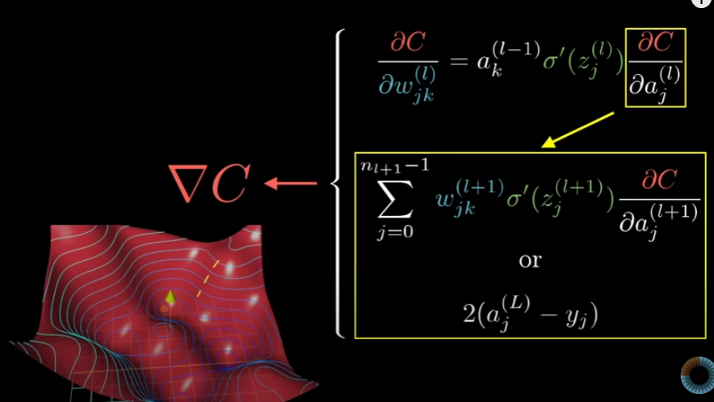

=> The chain rule expressions give us the derivatives that determine each component in the gradient that helps min the cost of the network by repeatedly stepping downhill.

* **Backpropagation :** Calculus to find the right direction -> decreasing the cost value.
  + Backpropagation uses derivatives to find the direction.

LLM explained

# What are large language models?

* **Step 1** : Pre-training:
* ***A large language model*** : a sophisticated(*phức tạp*) mathematical function that predicts what word comes next for any piece of text.
* Instead of predicting “**1 word**” with certainty, what it does is assign a probability to all “**possible next words**”.
* ***Models*** : learn how to make these predictions by processing an enormous amount of text, typically pulled from the internet.
* ***Training*** : tuning the dials on a big machine.
* The way that a LLM behaves is entirely determined by these many different continuous values, usually called “**parameters**” or “**weights**”

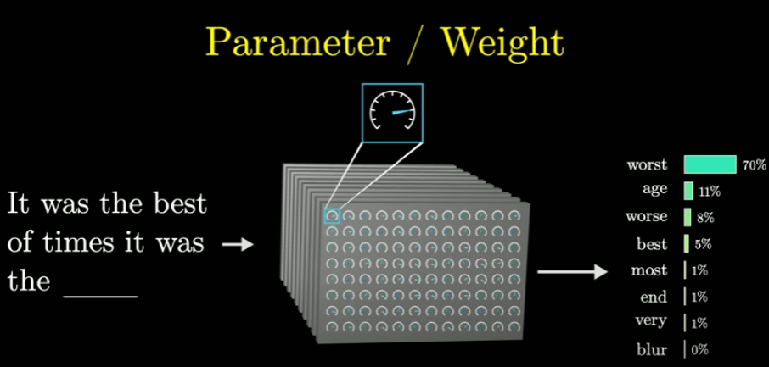

* + Changing those parameters -> change the probabilities that the model gives for the next word on a given input.
* ***Large*** : is how LLMs can have hundreds of billions of these parameters.
  + Those parameters begin at random -> The model just outputs gibberish(*vô nghĩa*), but repeatedly refined based on many example pieces of text.
* **The way this works** : pass in all but the last word from that example into the model and compare the prediction that it makes with the true last word from the example.

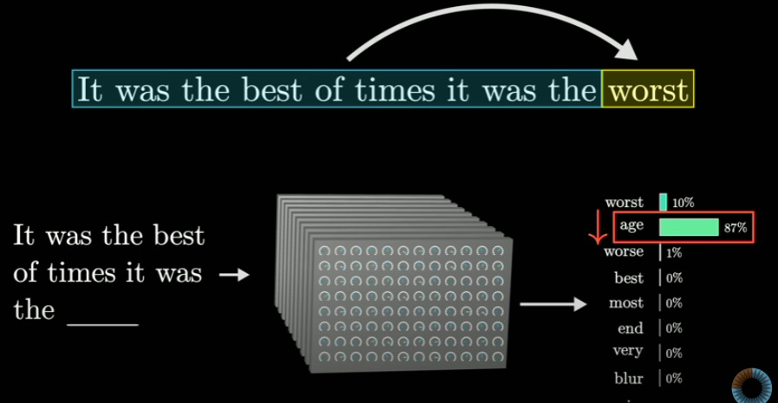

* + => Use ***backpropagation*** to tweak(*fix*) all of the parameters in such a way that it makes the model a little more likely to choose the true last word and a little less likely to choose all the others.
* When we do this for many trillions of examples :
  + The model starts to give more accurate(*chính* *xác*) predictions on the training data.
  + It starts to make more reasonable predictions on text that it’s never seen before.
* The goal of auto-completing a random passage of text from the internet is different from the goal of being a good AI assistant.
* This step is only possible by using special computer chips that are optimized for running many operations in parallel (GPUs)

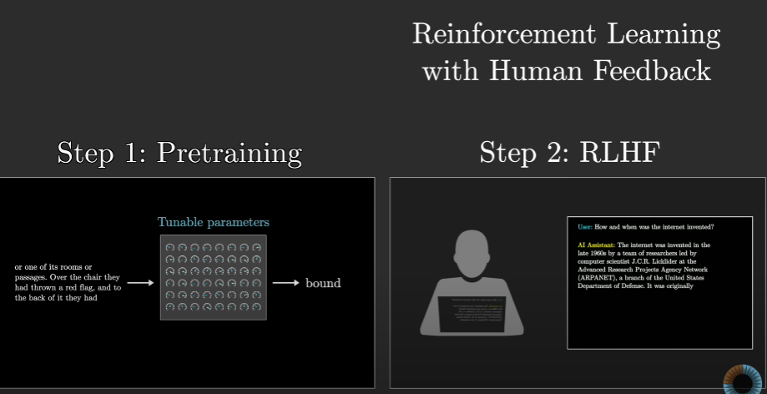

* **Step 2** : Reinforcement Learning with Human Feedback : RLHF  
  (In Chatbots)
* In this step, we have a new model : **transformer**.
* **Transformers** don’t read text from the start to the finish -> They soak it all in at once, in parallel.

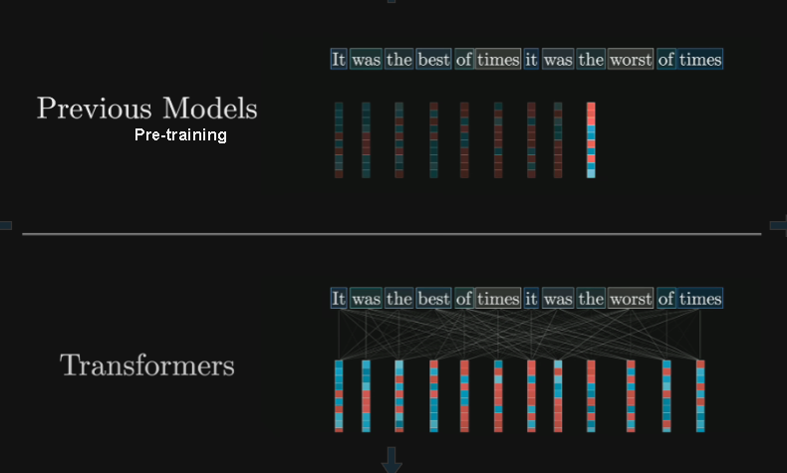

* Inside a transformer :
  + The very first step, the most other language models for that matter, is associated each word with a long list of numbers (*the vector is corresponding to a word*)
  + The reason for this -> The training process only works with continuous value -> we have to encode language using numbers -> Each of these lists of numbers may encode the meaning of the corresponding word.
* **Transformer** is ***unique*** : their reliance on a special operation : ***attention***.

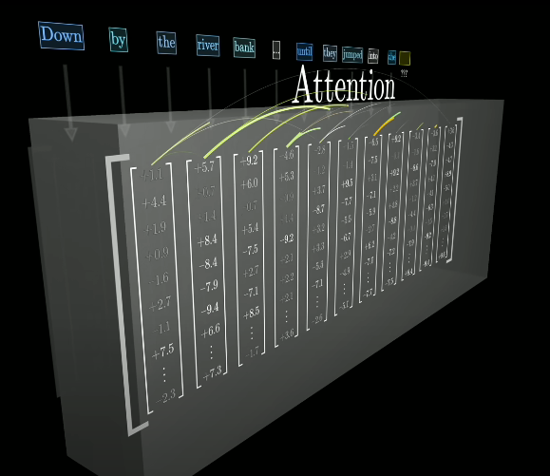

* Transformers include a second type of operation : **a feed-forward neural network** -> Give the model extra capacity(*dung tích*) to store more patterns about language learnt during training.

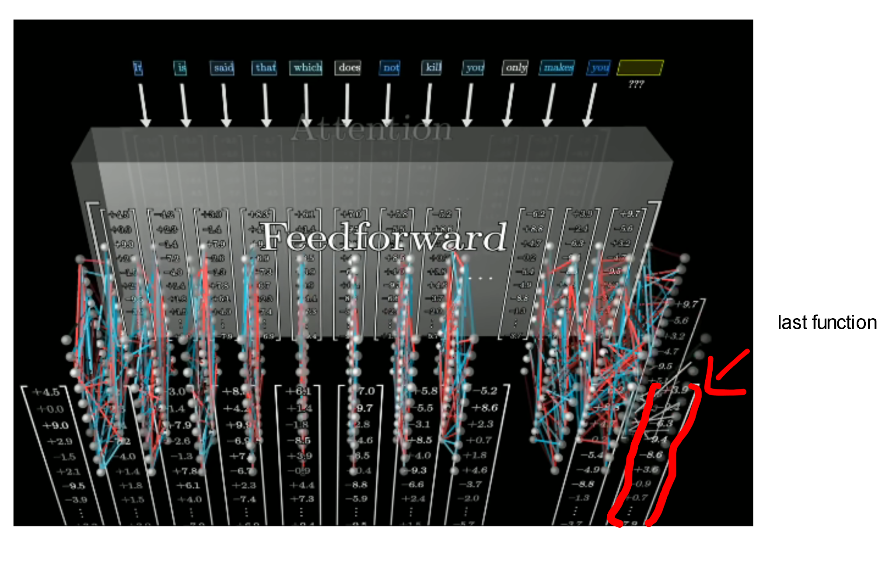

* All of this data (both attention and feedforward) repeatedly flows through many different iterations of these 2 fundamental operations.
* The last final function is performed on the last vector in this sequence, which has had a chance to be influenced by all the other context from the input text, as well as everything the model during training -> To produce a prediction of the next word.  
  => The model’s prediction looks like a probability for every possible next word.

Transfromers ( how LLMs works) explained visually

Transformer is T in GPT ( *Generative Pre-trained Transformer* )

# Inside a transformer :

* The input is broken up into a bunch of little pieces

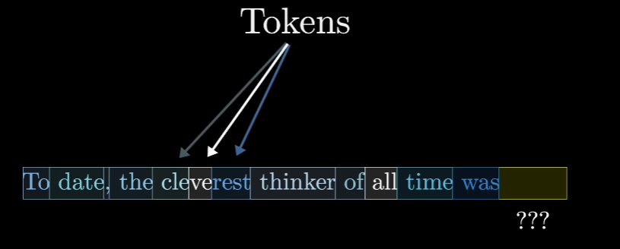

* The tokens tend to be words or little pieces or works or other common character combinations.
* If a sound or a picture are involved, the tokens could be little patches of that image or little chunks of that sound.

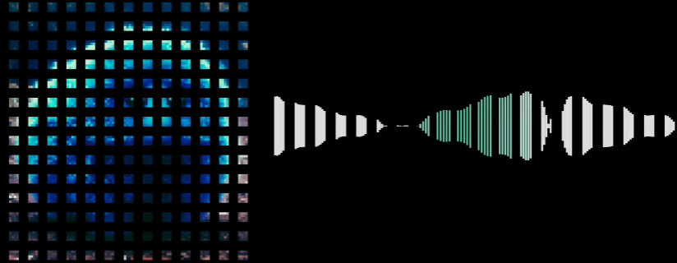

* Each one of these tokens is then associated with a vector - meaning some list of numbers which is meant to somehow encode the meaning of that piece.  
  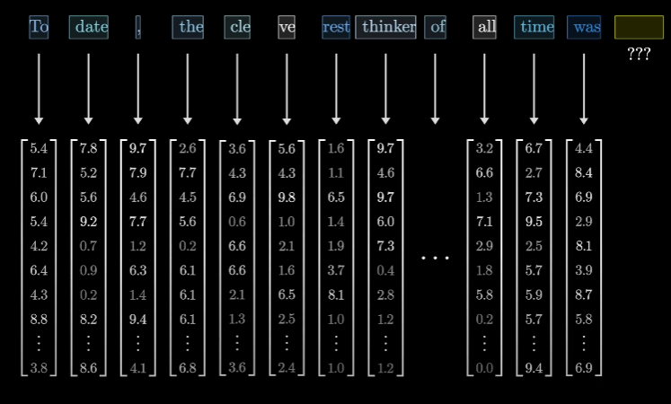
  + This sequence of vectors then passes through an operation that’s known as an ***attention block*** **->** the vector to talk to each other and pass information back and forth to update their values.
  + These vectors pass through a different kind of operation and depending on the source that we are reading ( ***a multi-layer perception*** or ***a feed -forward layer*** ) **->** The vectors don't talk to each other, they all go through the same operation in parallel  
    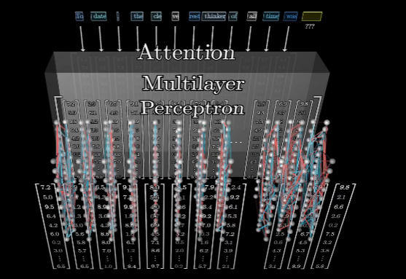
* All of the operations in both these blocks look like a giant pile of matrix multiplications.  
  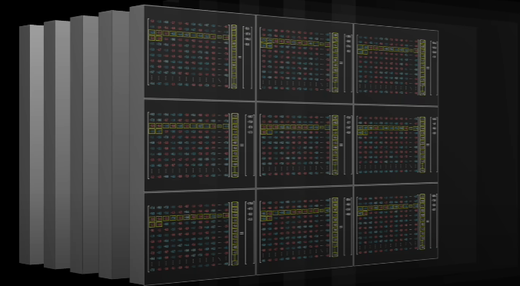
* **Goal** : Understand how to read the underlying matrices.
* We go and forth between Attention Block and multi-layer perceptron block, until at the very end the hope is that all of the essential meaning of the passage has somehow been baked into (*được đưa vào*) the very last vector in the sequence.

# The premise of Deep Learning :

* This is one approach to machine learning, which describes any model where we are using data to somehow determine how a model behaves.
* Between input and output, we will use **tunable parameters (*weight*)** instead of doing the task in code, like using many examples of what the output should look like for a given input to tweak and tune the values of those parameters to mimic the behavior.
* **Deep learning** **model** gets much more complicated.
  + Example : GPT-3 has 175b parameters.-> We cant create some giant model with a huge number of parameters without it either grossly overfitting the training data or being completely intractable to train.
* **Deep learning** : describe a class of models that in the last couple decades (*hàng thập kỉ qua*) have proven to scale(*mở rộng*) remarkably well.
  + These models have to follow a certain specific format :

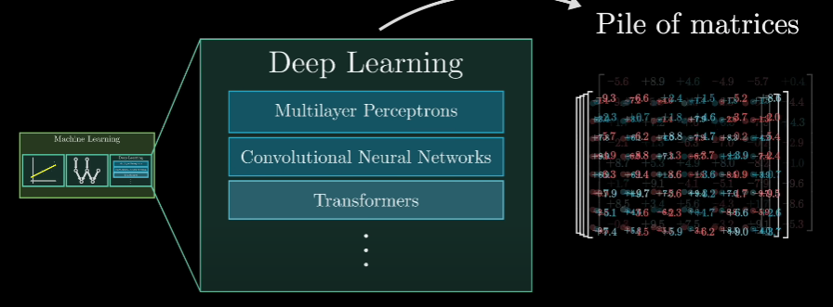

* + - Example : the input has to be formatted as an array of real numbers. -> A list of numbers, it could be a two-dimensional array or very often deal with higher dimensional arrays where the general term used is tensor
    - **Input data** : Being progressively transformed into many distinct layers, where again, each layer is always structured as some kind of array of real numbers, until we get to a final layer which we consider the output.

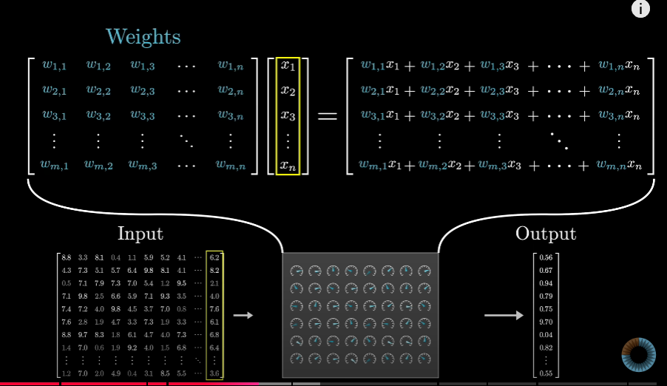

* + - * Example : There are total 175,181,291,520 weights in GPT-3
        + Organized into 27,938 matrices.
* **Weight** of the model - blue or red. <-> The **brain** : learn during training and determine how it behaves (define)
* **Data** being processed - gray. <-> Simply encodes : The processes of the model  
  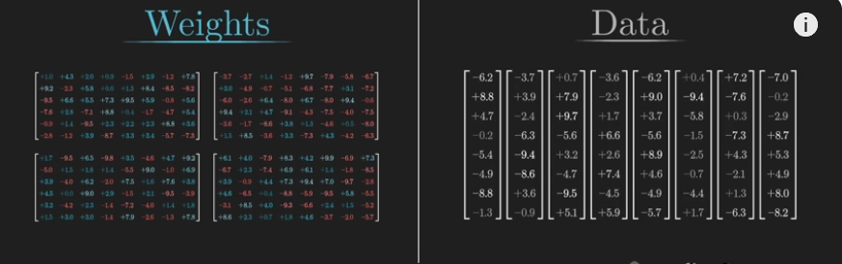

# Word embeddings : $W_{E}$

* The first matrix that we will encounter is “The embedding matrix” - has a single column for each one of those words  
  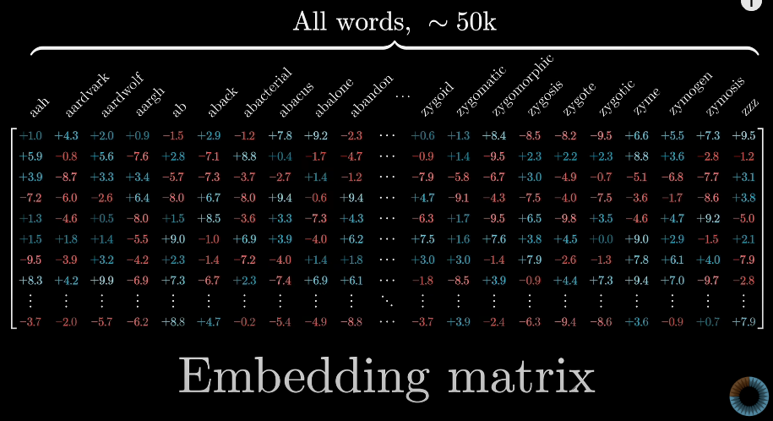
  + These columns are what determines what vector each word returns into in that step.
* The embedding a word - invites us to think of these vectors very geometrically as points in some high dimensional space.  
  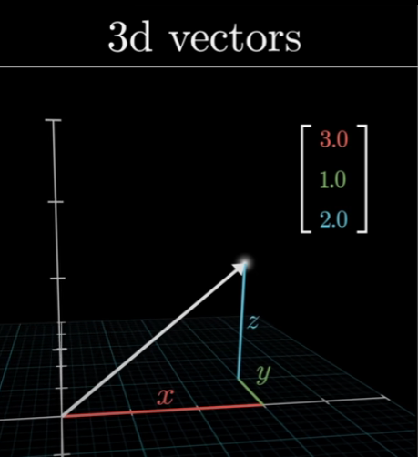
* Example :
  + How if we take the difference between the vectors for woman and man - visualize as a little vector connecting the tip of 1 to the tip of the other.
  + It's similar to vector king and queen :   
    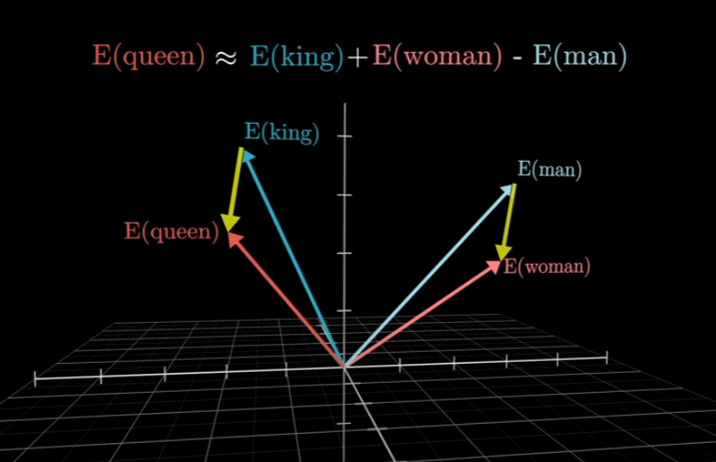
  + If we don’t know ‘*Queen*’-> We can find it by taking, adding the woman-man direction and searching for the embeddings closest to that point
* The truth -> The embedding of the specific thing is actually a little farther off than the suggestion ***because*** the way specific thing is used training data is not merely that.
* Like that example : If we add 1 thing and a country , next sub thing’s country -> We will get country’s thing

| * Thing + Country - Thing’s country ≈ Country’s Thing |
| --- |

* **Dot product** :
  + Dot product of 2 vectors can be thought of as a way to measure how well they align.
  + Dot products involve : multiplying all the corresponding components and then adding the results   
    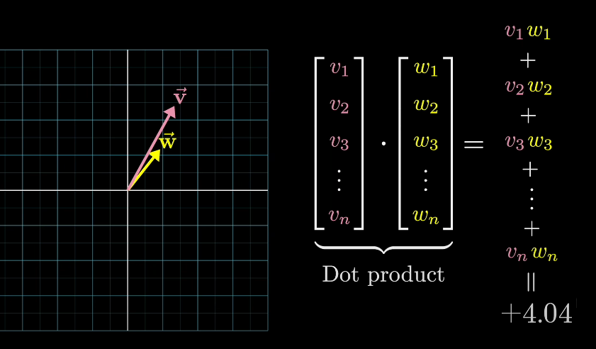
  + The dot product :
    - positive when vectors point in similar directions.
    - zero if they’re perpendicular (vuông góc)
    - negative whenever they point in opposite directions.

**=>** ***The embedding matrix*** - The columns tell us what happens to each word.

# Embedding beyond words :

* The meaning of a word is clearly informed by the surroundings, sometimes this includes context from a long distance away.
* The **goal** : empower it to incorporate(kết hợp) context efficiently.
* The **primary goal** : enable each one of those vectors to soak up a meaning that’s much more rich and specific than mere individual words could represent.

# Unembedding : $W_{U}$

* Unembedding is at the very end matrix.
* Involve 2 steps :
  + Use another matrix that maps the very last vector in the context to a list of 50000 values - one for each token in the vocabulary.
  + “**Softmax**” will normalize that into a probability distribution (phân phối xác suất).

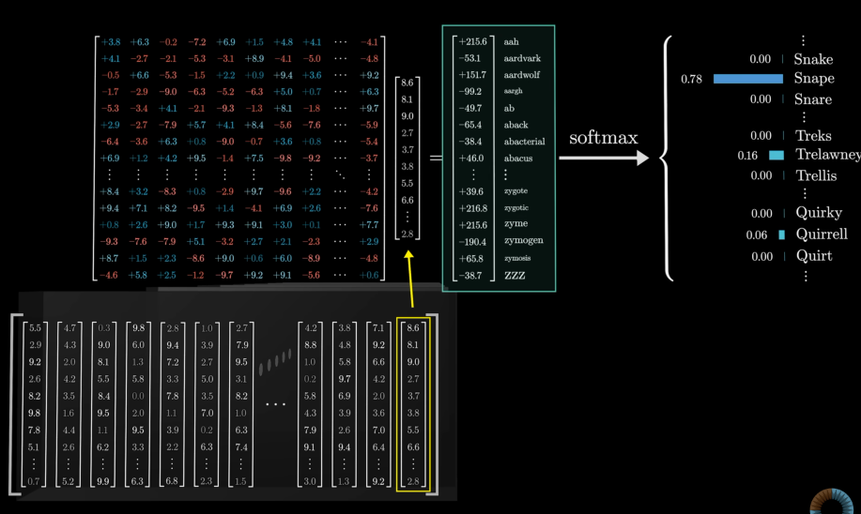

* + Except for the very last vector , other vectors in the layer are just sitting there with their own context-rich meanings.
* Like all the weight matrices, its entries begin at random, but they are learned during the training process.
* Unembedding matrix has 1 row for each word in the vocabulary - Each row has the same number of elements as the embedding dimension.

# Softmax with temperature :

* Softmax function makes another appearance for us once we dive into the attention blocks.
* Softmax is the standard(*chuẩn*) way to turn an arbitrary(*tùy ý*) list of numbers into a valid distribution in such a way that the largest values end up closest to 1, and the smaller values end up very close to 0.  
  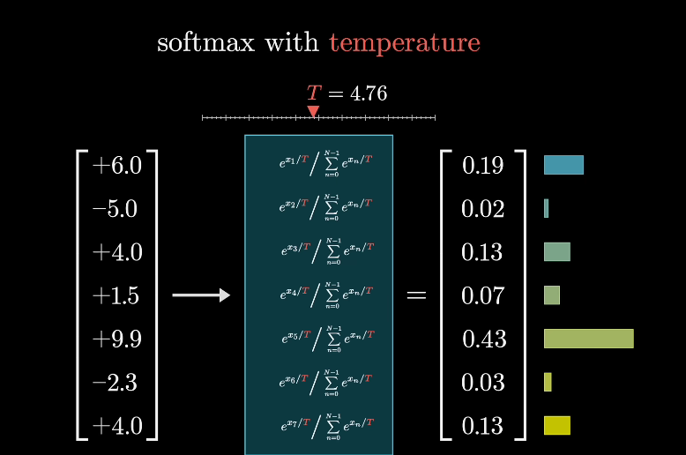
  + When T is larger -> We give more weights to the lower values -> The distribution is a little bit more uniform.  
    => always go to the most predictable word.
  + When T is smaller -> The bigger values will dominate more aggressively, where in the extreme, setting t equal to 0 means all of the weight goes to max value.  
    => tend to choose less likely words but it comes with risk.

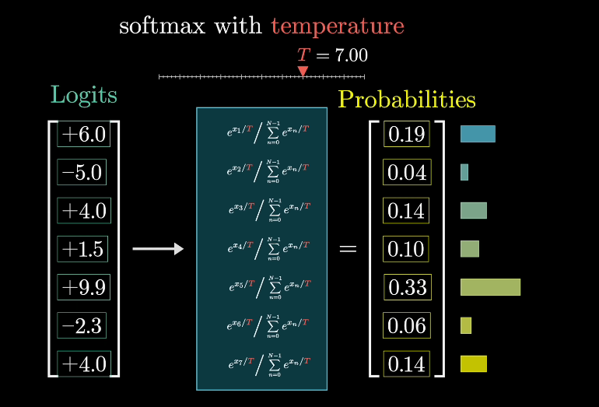

* + In an unembedding matrix , ML people would refer(*call…as*) to the components in that raw, unnormalized output as the logits for the next word prediction.

Attention in transformers, visually explained

The Goal : Take in a piece of text and predict what word comes next.

* 1 word in each sentence can have many meanings but has the same vector because this initial token embedding is effectively a lookup table with no reference to the context.

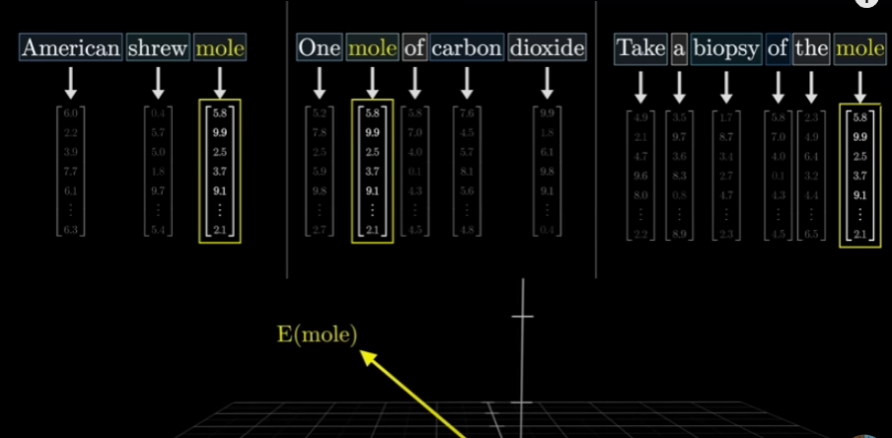

* Generally, the attention block allows the model to move information encoded in 1 embedding to that of another, potentially pens that are quite far away and potentially with information that’s much richer than just a single word.

# The attention pattern :

* The entries of the vector are enough to tell us both what the word is and where it exists in the context.
* The **goal** -> Have a series of computations produce a new refined set of embeddings where.
  + Ex : Nouns have ingested (*tiếp* *thu*) the meaning from their corresponding adjectives.
* The process :
  + First step : Image each noun, like creature - asking the question “are there any adjs sitting in front of me?”
    - The words fluffy and blue, to each be able to answer YES.
  + That question is encoded as yet another vector, another list of numbers - The ***query*** for this word.
* *The first matrix* : “***The query matrix”***

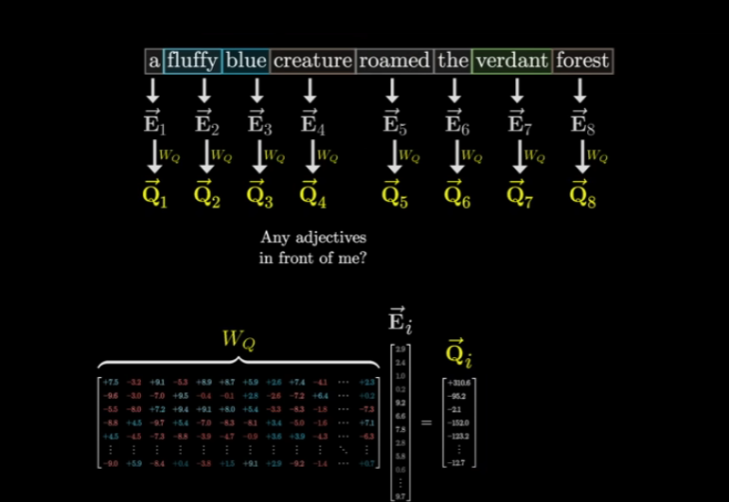

* The entries of the matrix $W_{Q}$ are parameters of the model -> The true behavior is learnt from data, and in practice, what this matrix does in a particular attention head is challenging to parse (*phân* *tích*).
* *The second matrix* : “***The key matrix***” which we also multiply by all of the embeddings => Produce a second sequence of vectors : “***The keys***”
  + “***The key matrix***” is full of tunable parameters and just like the query matrix maps the embedding vectors to that same smaller dimensional space.

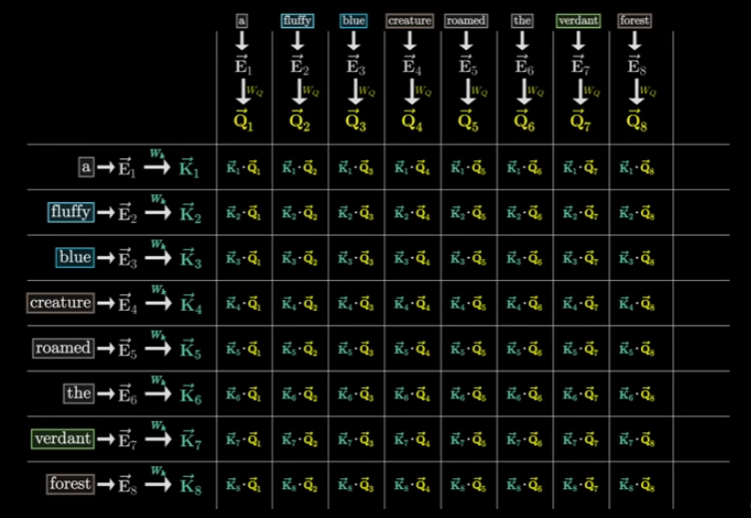

* + The keys produced by “fluffy” and “blue” really do align closely with the query produced by “creature” -> dot products in these 2 spots would be some large positive numbers.

=> The embeddings of “fluffy” and “blue” ***attend to*** the embedding of creature.

* Each column as giving weights according to how relevant the word on the left is to the corresponding value at the top   
  => ***An attention pattern***.

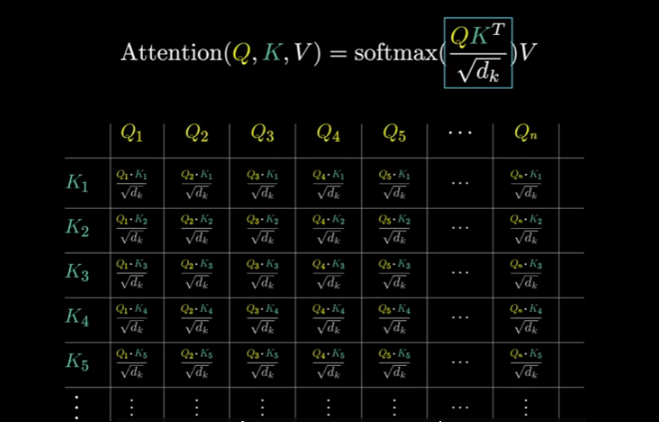

# Masking :

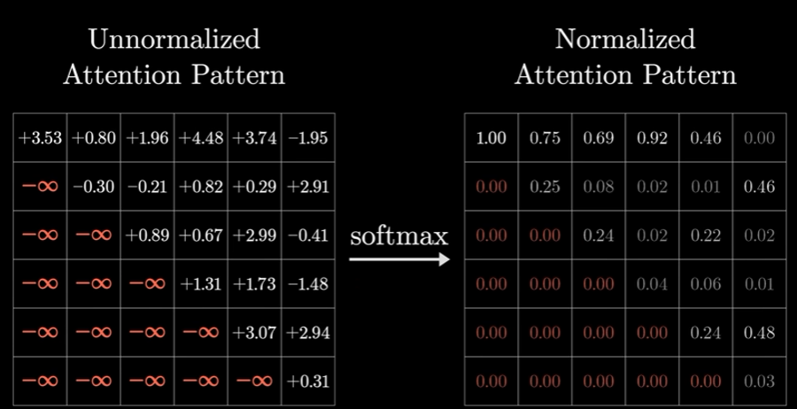

* Set all of the lower half entries to be negative infinity -> After applying softmax, all of those get turned zero, but the column stays normalized. = > ***Masking***

# Values :

* *The third matrix* : “***The value matrix***” - multiplied by the embedding of the first word (adj) => We will have “value vector”.

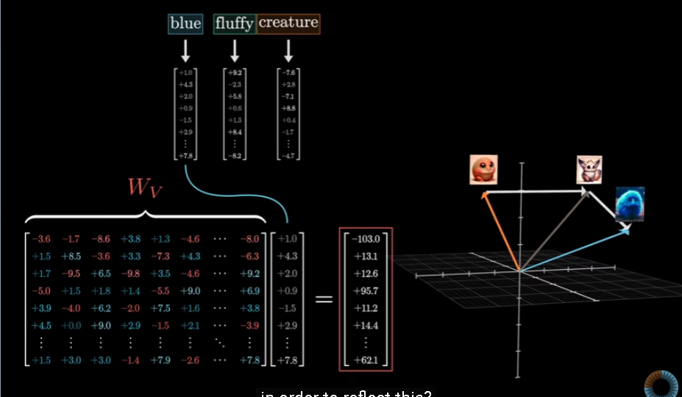

* In the diagram :
  + For each column, we multiply each of the value vectors by the corresponding weights in that column.

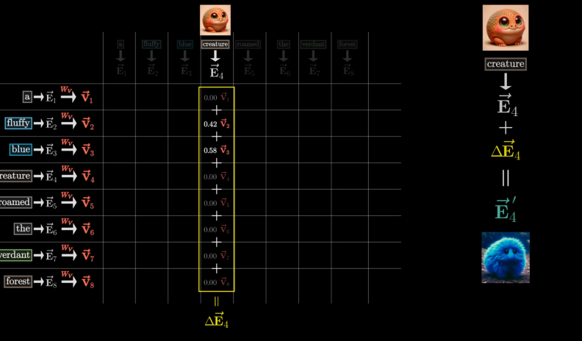

* + Adding together all of those rescaled values in the column, producing a change that we want to add : delta-E.
  + Then add that to the original embedding.
  + Do the same thing with other columns, -> Adding all of those changes to the corresponding embeddings, produces a full sequence of more refined embedding popping out of the attention block.

# Counting parameters :

* This process is parameterized by 3 distinct matrices :
  + The key
  + The query
  + The value.
* Example : In Chat GPT 3
  + These *key* and *query* matrices each have 12288 columns, matching the embedding dimension, and 128 rows, matching the dimension of that smaller key query space.  
    => Give us an additional 1.5 million or so parameters for each one.
  + The *value* matrix has 12288 columns and 12288 rows -> Both inputs and outputs live in this very large embedding space.

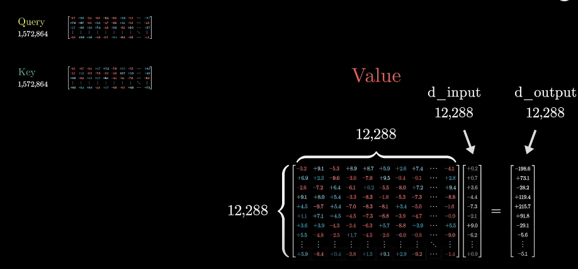   
=> That would mean about 150m added parameters.

* We could devote the orders of magnitude more parameters to the value map than to the key and query.
* In practice, it is much more efficient if instead we make it so that the number of parameters devoted to this value map is the same as the number devoted to the key and the query.

| #**Value params = (**#**Query params) + (**#**Key params)** |
| --- |

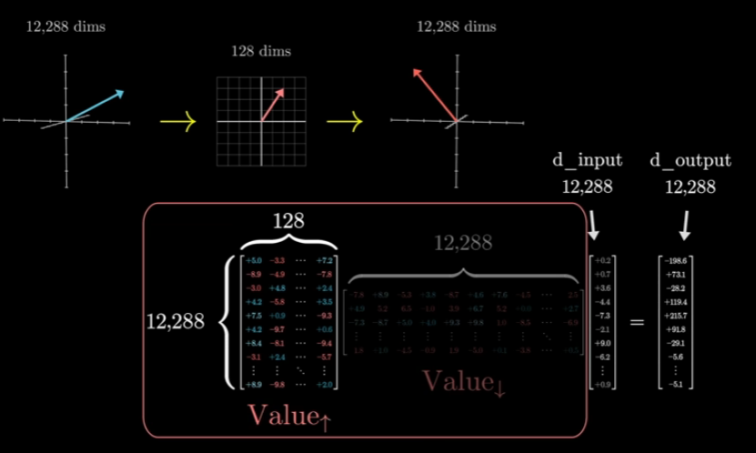

* In value matrix, we divide into 2 submatrices:
  + Value down matrix : Has a smaller number of rows :   
    128 rows and 12288 columns.
  + Value up matrix : Maps(ánh xạ) from the smaller space back up to the embedding space -> producing the vectors that we use to make the actual updates.  
    12288 rows and 128 columns.

=> We have the final params :

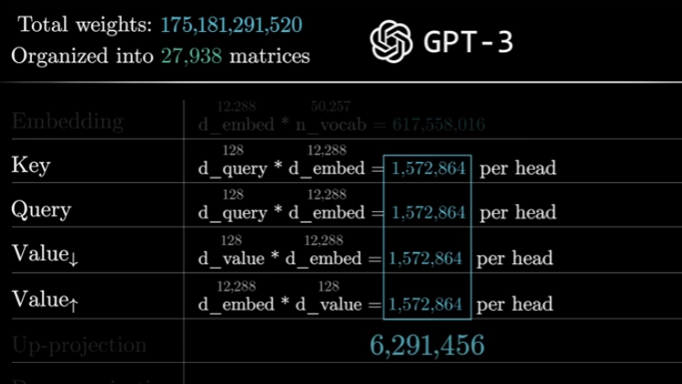

# Cross-attention :

* Cross attention : Distinguish(phân biệt) everything from a variation that comes up in other models.
  + Involve models that process 2 distinct types of data
    - text in 1 language and text in another language that’s part of an ongoing generation of a translation.
    - audio input of speech and an going transcription.
* A cross-attention head looks almost identical.
  + The only difference : The key and query maps act on different data sets.
  + Ex: The keys might come from 1 language, while the queries come from another => The attention pattern could describe which words from 1 language correspond to which words in another.
* This setting would typically be no ***masking*** since there’s not really any notion of later token affecting earlier ones.

# Multiple heads :

* **Multiple heads** : a full attention block inside a transformer consists of multi-heads attention, where we run a lot of those operations in parallel, each with its own distinct key query and value maps.
* For every different type of contextual updating that we might imagine, the parameters of those key and query matrices would be different to capture the different attention patterns, and the parameters of our value map would be different based on what should be added to the embeddings.
* Example : GPT-3 uses 96 attention heads inside each block :

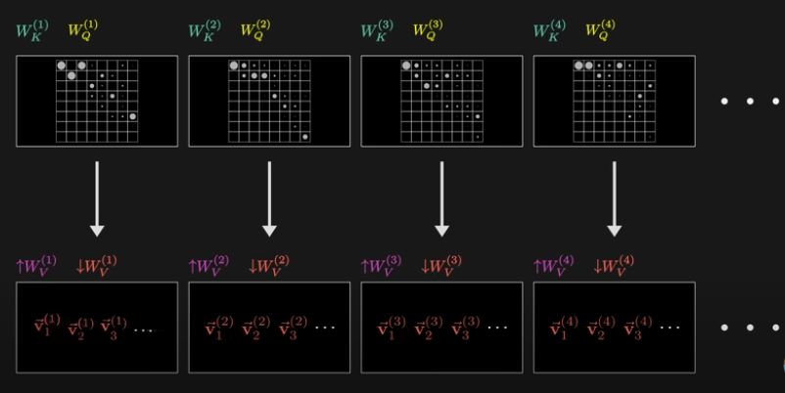

* + This has 96 distinct key and query matrices producing 96 distinct attention patterns -> each head has its own distinct value matrices used to produce 96 sequences of value vectors.
  + These are all added together using the corresponding attention patterns as weights -> Each position in the context, each token, everyone of these heads produces a proposed change to be added to the embedding in that position
  + Final : Sum together all of those proposed changes , and add the result to the original embedding of that position.

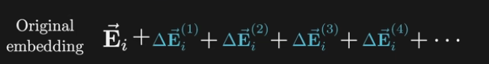

* + - -> This entire sum would be one slice of what’s outputted from this multi-headed attention block, a single one of those refined embeddings that pops out the other end of it

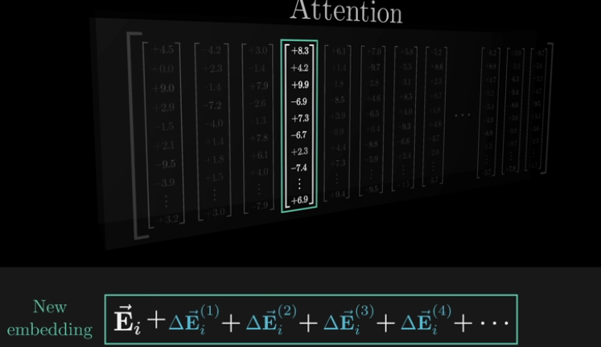

* ***The overall idea*** : Run many distinct heads in parallel, we’re giving model the capacity to learn many distinct ways that context changes meaning

=>

* + Pulling up the running tally for parameters count with 96 heads, each including its own variation of these four matrices, each block of multi-headed attention ends up with around 600m parameters.

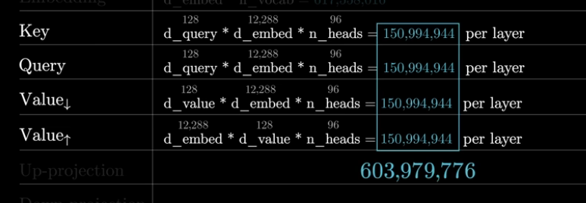

# The output matrix :

* ***The output matrix*** : All of value up matrices of every head appear stapled(*chủ yếu*) together in 1 giant matrix, associated with the entire multi-headed attention block.

How might LLMs store facts

**** : What happened inside multi-layer perceptrons (MLP) - which make up the other big portion of the network?

# Quick refresher on transformers :

* The input text is first broken into a bunch of tokens - little chunks that are typically words or little pieces of words
  + Each token is associated with a high-dimensional vector ( a long list of numbers )

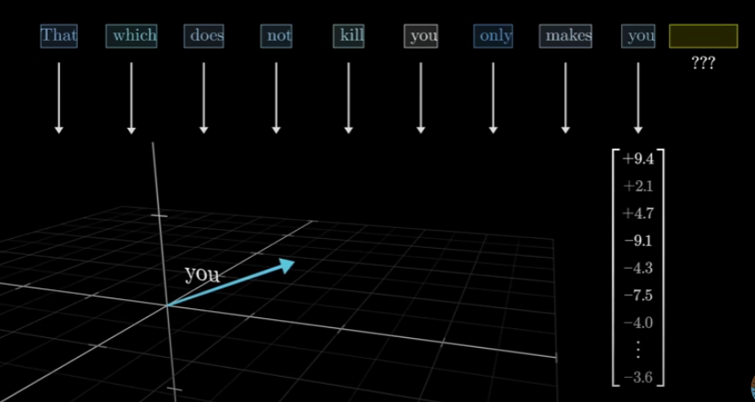

* + This sequence of vectors repeatedly passes through 2 kinds of operations :
    - **Attention** : Allows the vectors to pass information between 1 another
    - **Multi-layer perceptrons** :

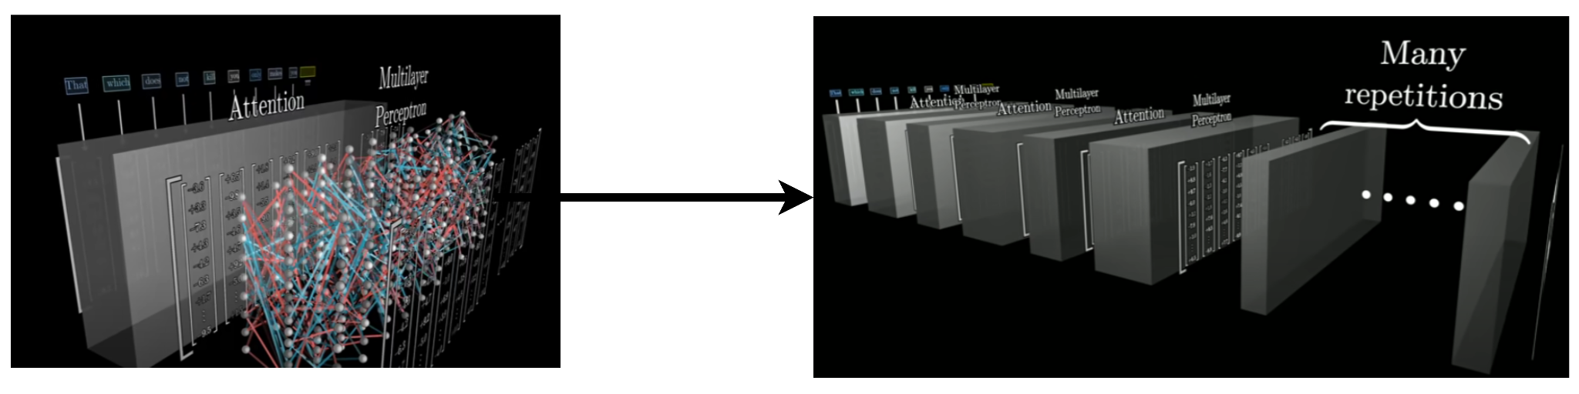

* These vectors don’t merely encode the meaning of a single word -> They imbibe a much richer meaning based on all the context around them and also based on the model’s knowledge.

**** : The majority of the model parameters actually live inside the MLP blocks => They offer extra capacity to store facts

# Assumptions for toy example :

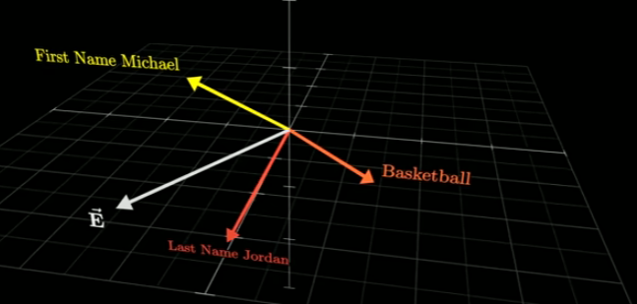

* Summarization :
  + The dot product with the first name “Michael” direction =
    - 1 -> The vector to be encoding the idea of a person with that first name
    - 0 or negative -> The vector doesn’t really align with that direction.
  + The dot product with these other directions would tell us whether it represents the last name “Jordan” or “basketball”
  + A vector is meant to represent the full name “Michael Jordan” -> Its dot product with both the directions would have to be 1.
  + The text “Michael Jordan” spans 2 different tokens -> The first text has successfully passed information to the second of these 2 vectors so as to ensure it can encode both names.

# Inside a MLP :

* ***ReLU*** : Rectified Linear Unit

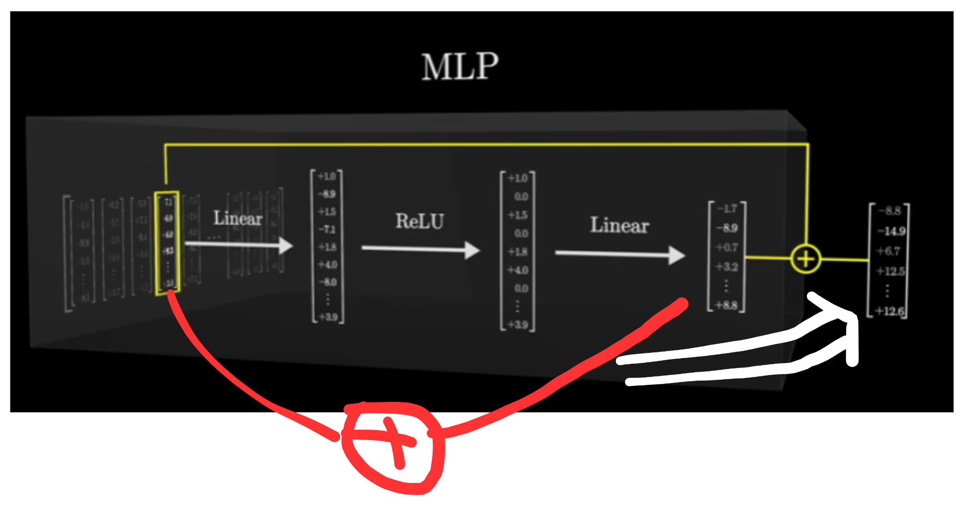

* This sequence of operations is something that we apply to every vector in the sequence, associated with every token in the input <-> It all happens in parallel
* In this step : The vectors don’t talk to each other, just doing their own thing.

***: Example : “Michael Jordan plays Basketball”

* If a vector flows in that encodes first name “Michael” and last name “Jordan” -> This sequence of computations will produce something that includes that direction ”basketball”, which is what will add on to the vector in that position.

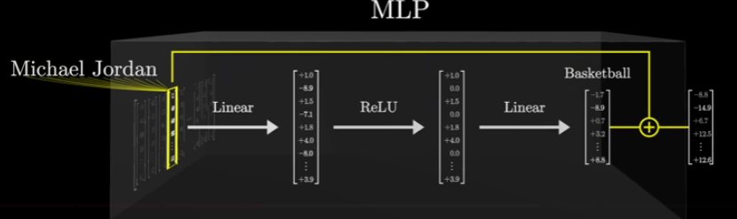

* 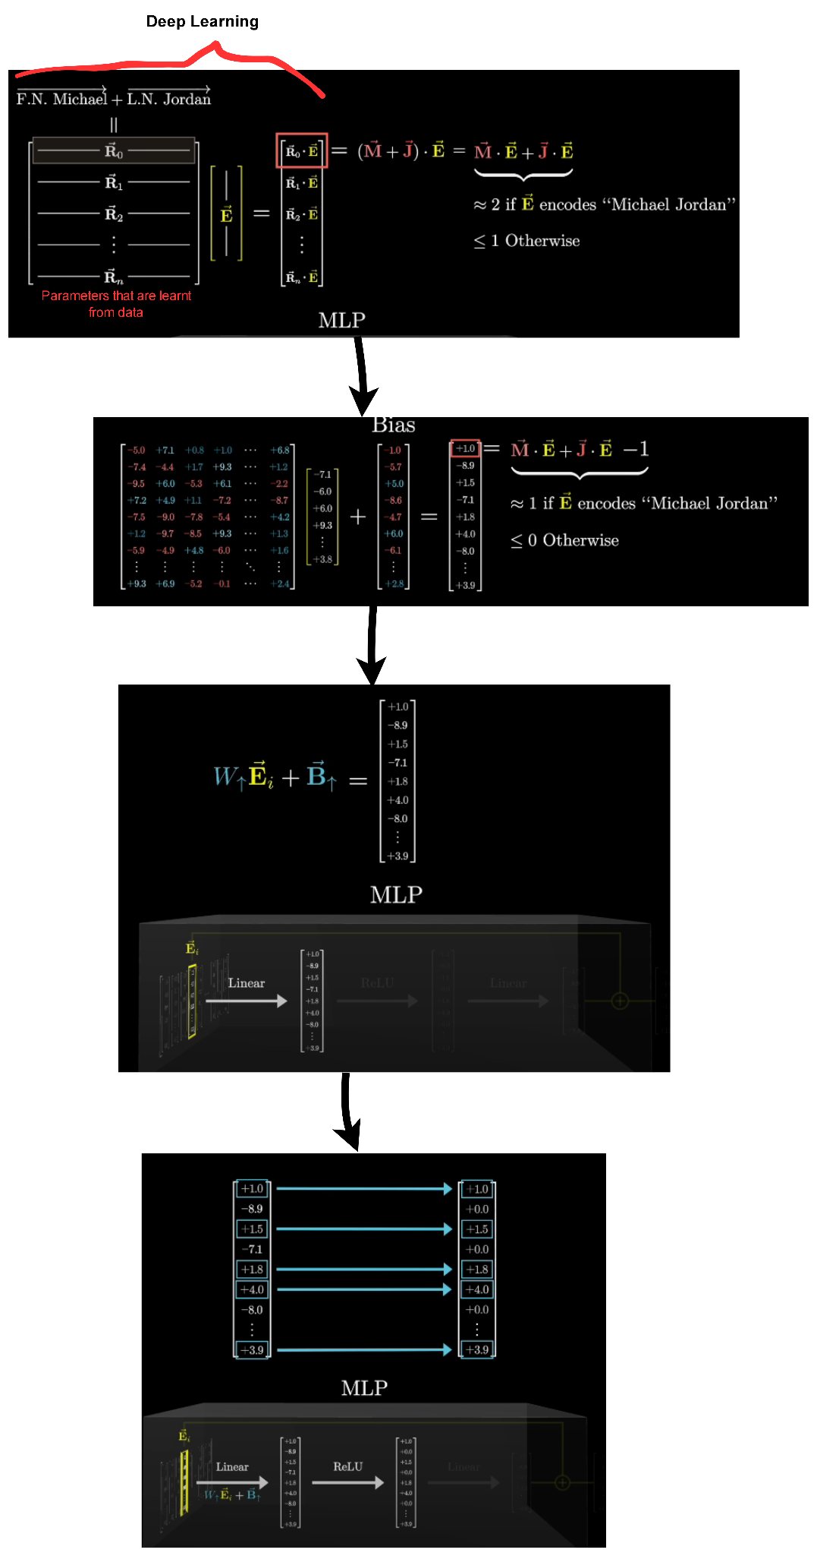
* **The first step** of this process is “**Deep learning**” : Multiplying that vector by a very big matrix. ***=> Think of it row by row***
* **Then**, this process includes adding another vector to the output : “**Bias**” :
  + Assume the very first component is negative one : -1
  + This will make the result cleaner.
* The total number of rows in this matrix, which is something like the number of questions being asked

****: The problem is that this operation is purely linear but language is a very non-linear process.

* **The next step** is to pass the large intermediate (2 vectors between **ReLU**) vectors through a very simple non-linear function.
  + The common choice : Take all of the negative values and map them to zero and leave all of the positive values unchanged.
  + Example : directly mimics the behavior of an **AND** gate.
    - If the first entry of the intermediate vector is 1 ⇔ the full name is “Michael Jordan” and 0 or negative otherwise
    - After passing it through the **ReLU**, we end up with a very clean value where all of the zero and negative values just clipped to 0 => the output = 0 for full name and 0 otherwise.

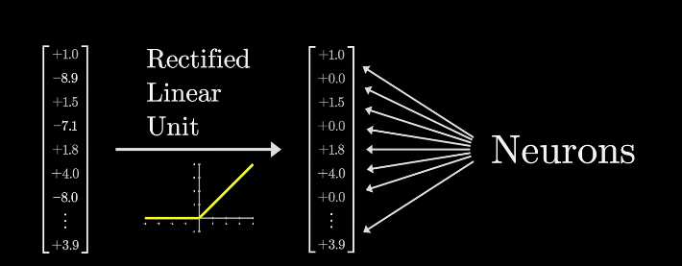

* + The **Neural Network** is the result vector ( after passing through the **ReLU**)
  + The neural network picture with a layer of dots and a bunch of lines connecting to the previous layer -> Convey(*truyền đạt*) the combination of a linear step, a matrix multiplication, followed by some simple term-wise nonlinear function like **ReLU**.

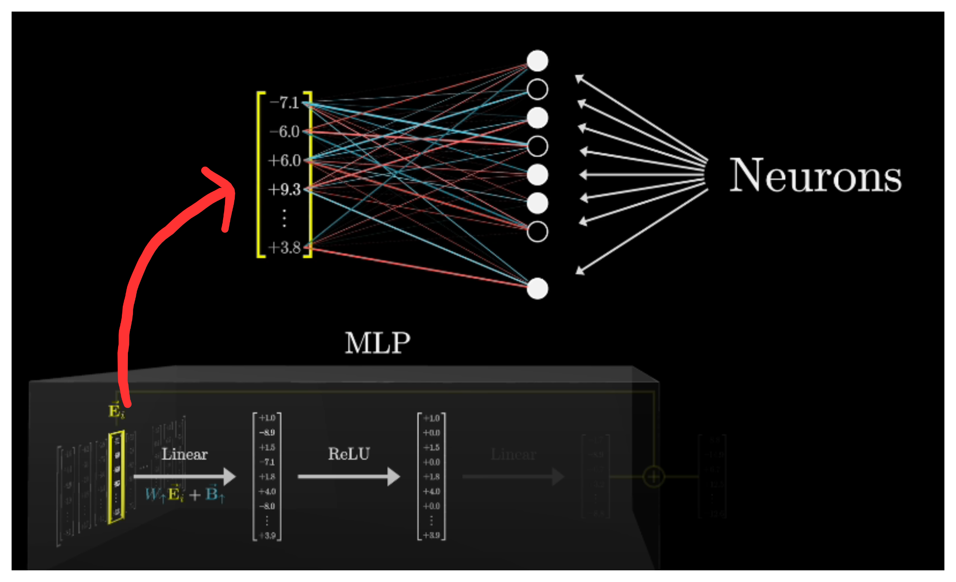

* + The neuron is “***active***” whenever the value is positive and that it is inactive if the value is 0.
* **The next step** (similar to the first step): Multiply by a very large matrix and we add on a certain bias term -> The number of dimensions in the output is back down to the size of that embedding space. ***=> Think of it column by column.*** (as the columns have the same dimension as the embedding space -> Think of them as directions in that space.)

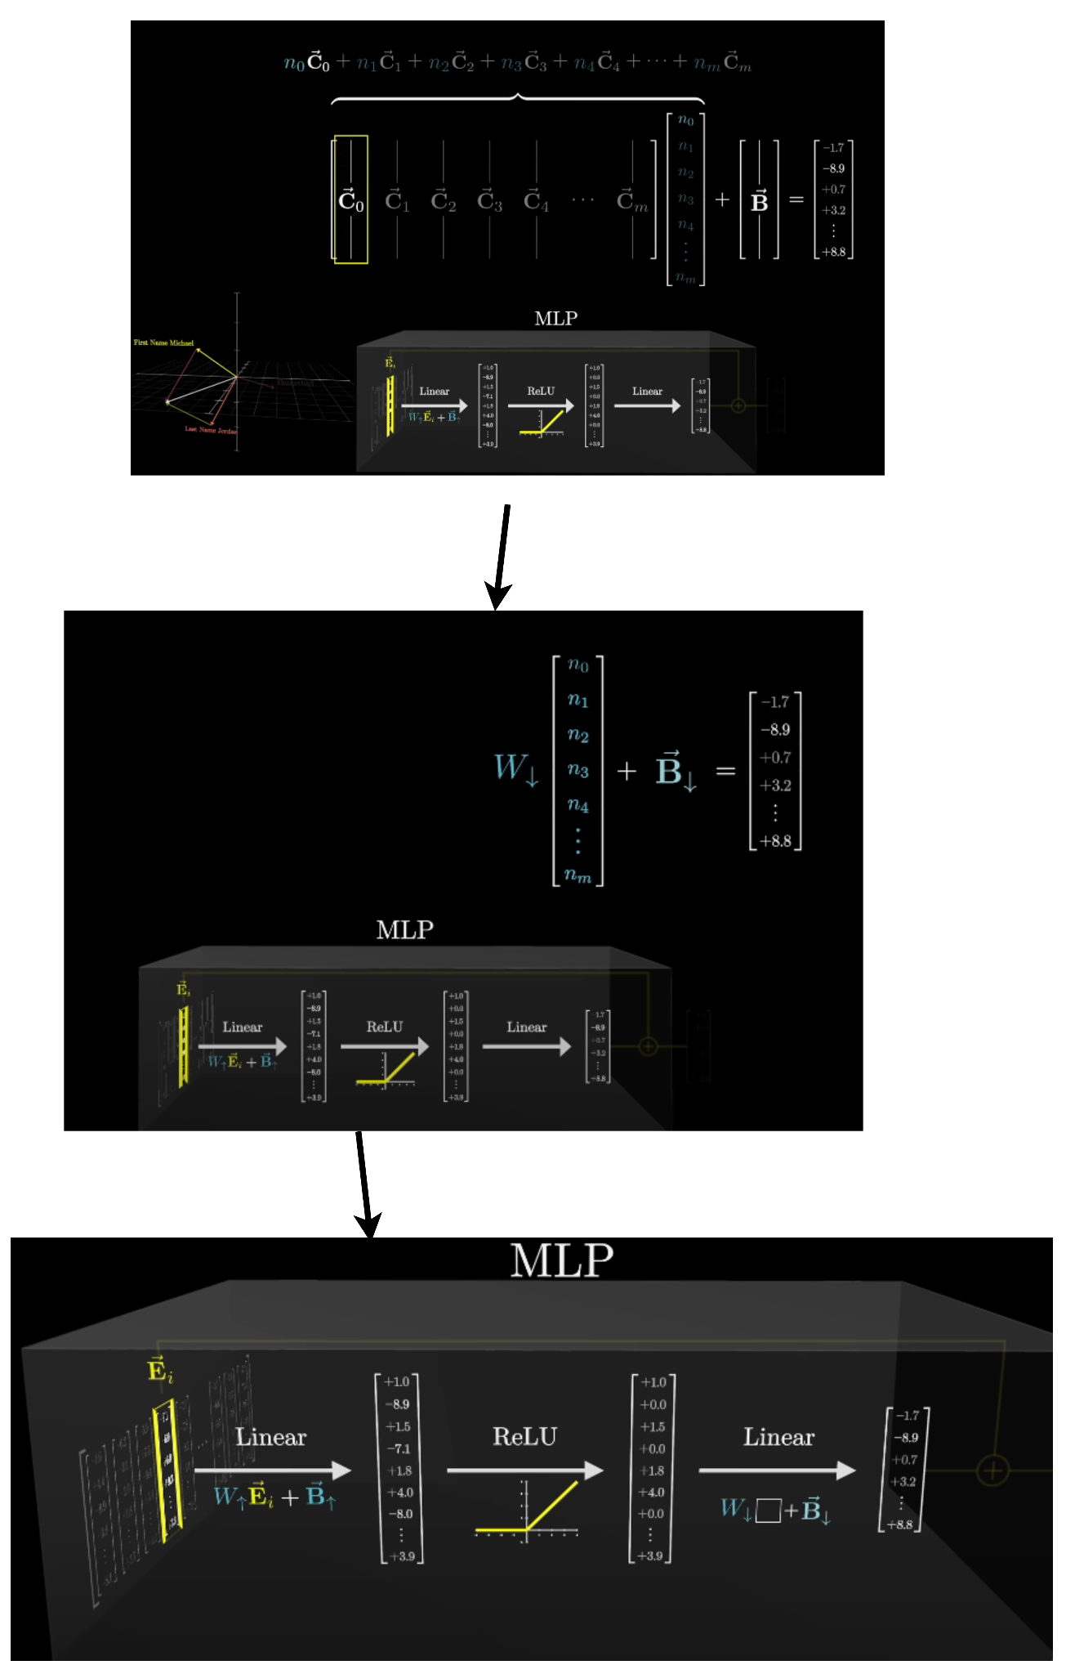

* When the relevant neuron in that first position is active -> Adding that column to the final result.
  + If that neuron was inactive, the number was zero -> That would have no effect.
* => This model could bake into that column and many other features that it wants to associate with something that is related to 1 thing that is mentioned.
* => All of the other columns in that matrix are telling what will be added to the final result if the corresponding neuron is active.
* **The final** : Add the result vector of the previous step ( the vector after the second linear of the process ) to the vector that flowed into the block at the position and that gets us the final result.
* This is a process happening to every one of those vectors in parallel.
* Example : 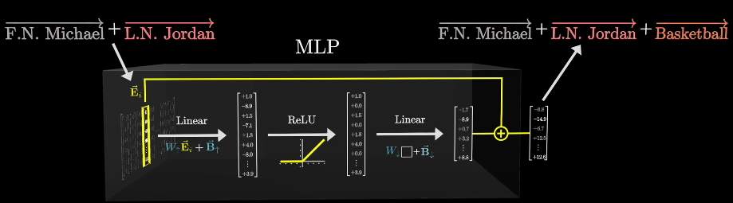  
  + GPT-3 numbers, this block doesn’t just have only 50,000 neurons in it, but it has also 50,000 times the number of tokens in the input.
* **2 points of reflection** :
  + A kind of bookkeeping
  + A very thought-provoking fact about higher dimensions.

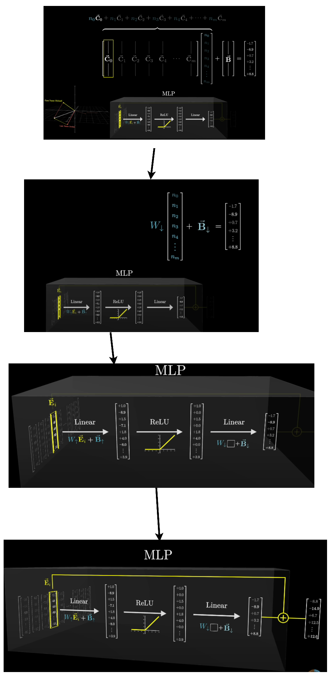

# Counting parameters : (GPT-3)

* In GPT-3, this up projection has just under 50,000 ( 4 x 12,888 ) rows, and each row matches the size of the embedding space, which for GPT-3 is 12,288

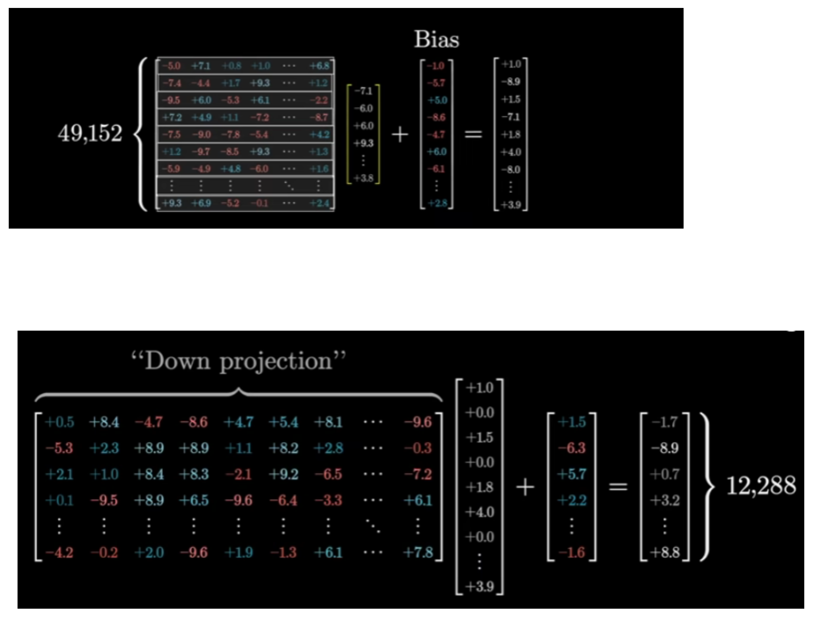

* => Multiply 2 together => We have 4 x 12,888 x 12,888 = 603,979,776 parameters *just for 1 matrix*.
* The down and up projection have the same number of parameters just with a transposed shape (*chuyển vị*).
* => Together, they give about 603,979,776 x 603,979,776 = 1,207,959,552.
* The ***Bias*** has accounted for a couple more parameters, but not too much ≈ 0.00008 of the total.
* In GPT-3, the sequence of embedding vectors flows through not 1, but 96 distinct MLPs -> the total of parameters devoted to all of these blocks adds up to about 1,207,959,552 x 96 = 115,964,116,992 ( only up, down projection ).
* And when we add it to every thing that we had :

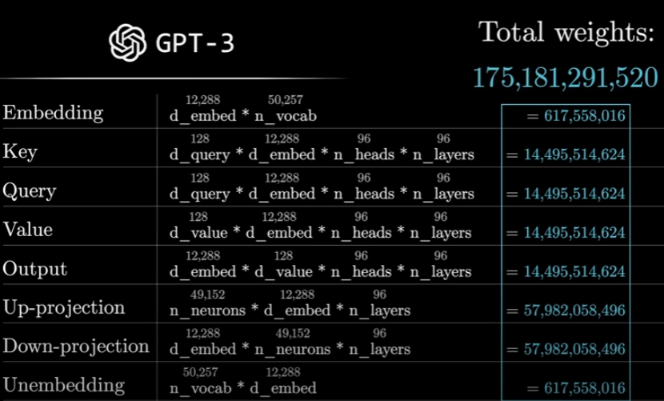

* The process :

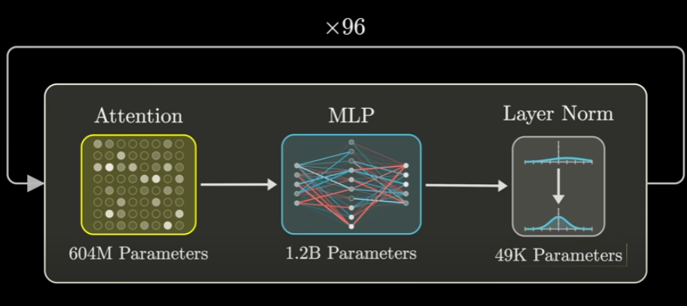

# Superposition :

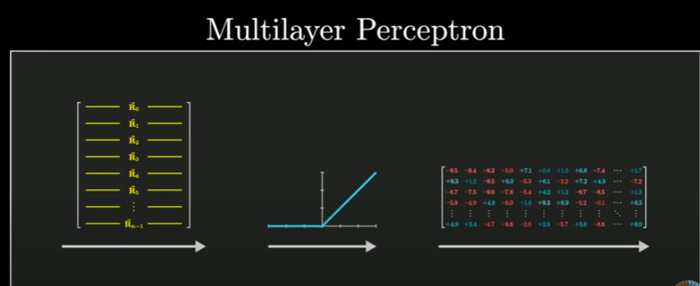

* The rows of that first matrix can be thought of as direction in this embedding space -> The activation of each neuron tells how much a given vector aligns with some specific direction.
* The columns of that second matrix tell what will be added to the result if that neuron is active.
* **Superposition** : a hypothesis that might help to explain both why the models are especially hard to interpret and also why they scale surprisingly well.
* Example : If we have an **n-dimensional** space, we want to represent a bunch of different features using directions that are all perpendicular (*vuông góc*) to 1 another in that space, the way if we add a component in 1 direction, it doesn’t influence any of the other directions -> Max number of vectors we can fit is only “**N**” - the number of dimensions.

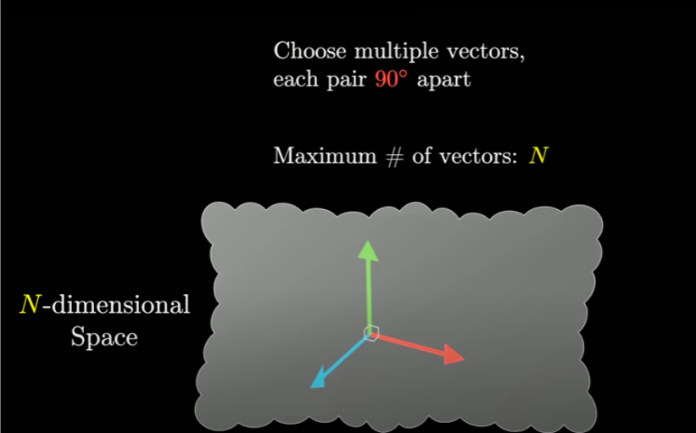

* Those features are represented by vectors -> Are not exactly perpendicular, they are just between 89 and 91 degrees apart.

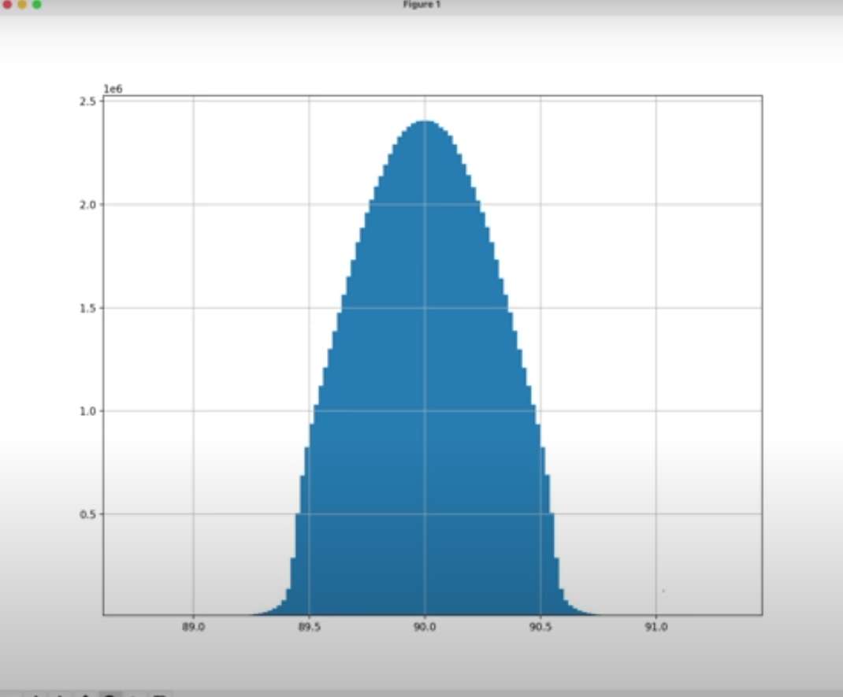

* If we have only 3 or small, it just makes it all the more counterintuitive for higher dimensions.
* A consequence of something known as Johnson-Lidenstrauss Lemma : The number of vectors we can cram into a space that is nearly perpendicular grows exponentially(*cấp số nhân*) with the number of dimensions.
* => This is very significant for LLMs, which might benefit from associating independent ideas with nearly perpendicular directions -> Possible for it to store many more ideas than there are dimensions in the space that it’s allotted.
* GPT-3 : it might not just be probing at 50,000 features, but if it instead leveraged this enormous added capacity by using nearly perpendicular directions of the space, it could be probing at many more features of the vector being processed.
  + If it was doing that -> individual features aren’t gonna be visible as a single neuron lighting up